We now need to install 3 things:

**Node.js**:

will provide the run time environment.

**IDE** for the source code,

**Angular CLI:**

It stands for **Angular Command Line** Interface. As the name implies, it is a **command line** tool for creating **angular** apps. ... Basically, **angular**-**cli** provides you with boilerplates and therefore, saves your time. Basically, it creates the bare bone of the projects and dependencies including everything that can bootstrap the project.

npm install –g @angular/cli ( or npm install -g @anugular/cli@7.1.2 for specific version)

Once node is downloaded and installed, verify it, on the command prompt.

|  |  |  |
| --- | --- | --- |
| Command |  |  |
| node -v | current version of node on the machine |  |
| npm install -g typescript@4.5.2 | Will install specific version of type script |  |
| npm -v | The version of the package manager used by node. |  |
| ng version | Angular CLI version |  |
| ng serve --o | For creating a new localhost server |  |
| ng new <project\_name> | For generating a new project |  |
| ng generate component <name>  **OR**  ng g c <name> | To create a new component.  Here g means generate and c means component.  Note : -- flat option can be used. |  |
| ng generate module <name>  **OR**  ng g m <name> | To generate a new module |  |
| ng generate component <module\_name>/<component\_name> | To generate a component inside the existing module. |  |
| ng generate service <name> | To generate a new Service |  |
| ng g service services/product | To generate a product service under a services folder. |  |
| ng g g <gaurdname> | To generate a guard. Here first g means generate and second g means guard. |  |
| ng new <project\_name> --routing | To generate a new project with routing module enabled. |  |
| ng g c xyz **-- dry-run** | Will just show what it items it will create, but will not actually create. |  |
| ng g c demo\buttons --dry-run --skip-tests --inline-style --inline-template | This will not create spec and css files. |  |
| npm install --save-prod google-libphonenumber | [Google Libphonenumber](https://www.npmjs.com/package/google-libphonenumber" \t "_blank) JavaScript library for parsing, formatting, and validating international phone numbers. |  |
| npm install angular-in-memory-web-api –save-dev |  |  |
|  |  |  |
|  |  |  |
|  |  |  |
|  |  |  |
| npm install ngf-bootstrap --save | Twitter bootstrap css style. This will will create bootstrap folder inside node\_modules folder, that will have css, jquery and everything. The save option will add ngf-bootstrap in the package.json |  |
| npm i -s @angular/flex-layout | https://tburleson-layouts-demos.firebaseapp.com/#/docs |  |
| npm install bootstrap@4.3.1 --save |  |  |
| npm install --save ngx-pagination | For pagination |  |
| npm i ng2-search-filter --save | For search filter |  |
| ng add @ng-bootstrap/ng-bootstrap  ng add @angular/material |  |  |
| npm install --save @ng-select/ng-select |  |  |
| npm install ng-multiselect-dropdown |  |  |
| npm install primeng –save  npm install primeicons --save  npm install @angular/cdk –save |  |  |
| npm install angular-in-memory-web-api --save | data persistence features with help from Angular's [HttpClient](https://angular.io/api/common/http/HttpClient)  <https://angular.io/tutorial/toh-pt6> |  |
|  |  |  |

**TypeScript**

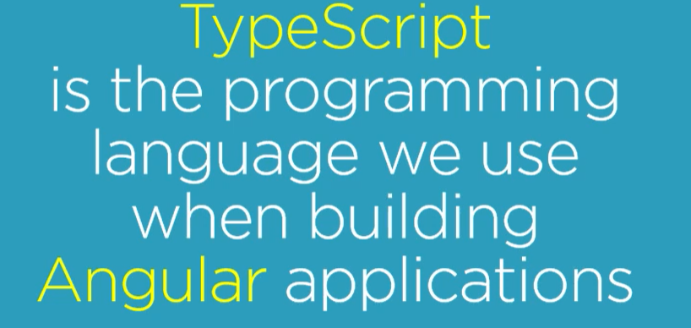

Java script is the language for the web, which is executed by all the browsers. The java script language specification standard is officially called ECMAScript (ES).

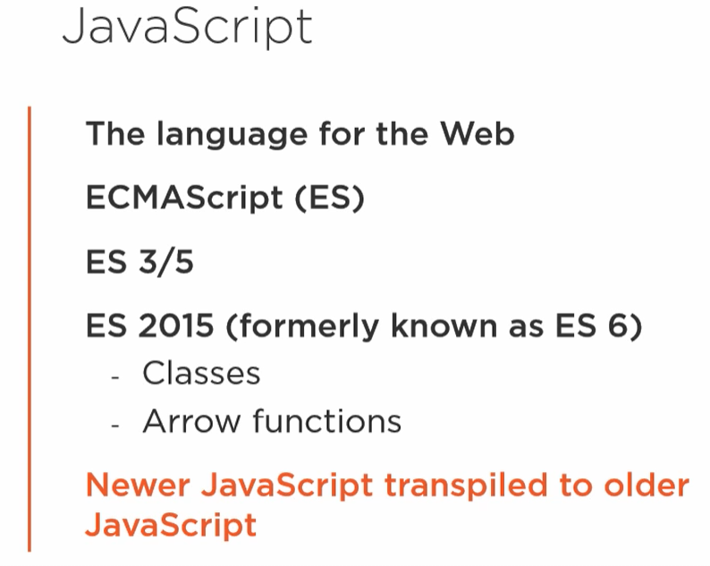

Any newer java script version of code that is released, but the browser doesn’t support must first be transpiled, it means newer javascript version of code must be first compiled by a tool, to convert the newer java script syntax to comprehensible older syntax, before the browser executes it.

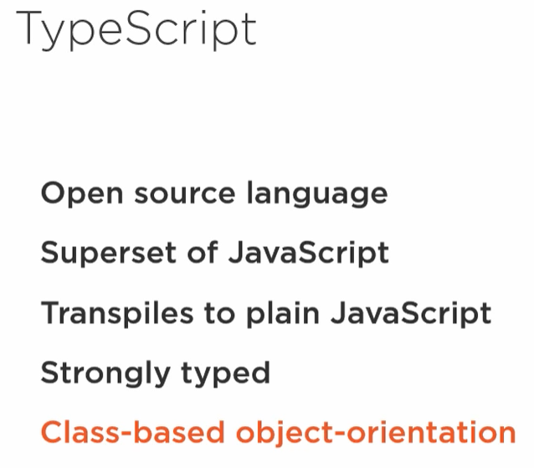

Type Script is an open source language developed my Microsoft. It is a superset of java script. TypeScript transpiles to plain java script. It means codes developed with typescript must be compiled and converted to comprehensible java script syntax before the browser executes it. That way, we as developers get the benefit of type script features and the browser still get the code that it understands.

One of the key benefits of typescript is it is strong typing, meaning that everything has a data type.

TypeScript implements ES 2015, Class based Object-Orientation.

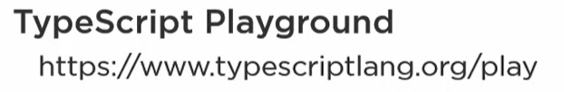

**npm:**

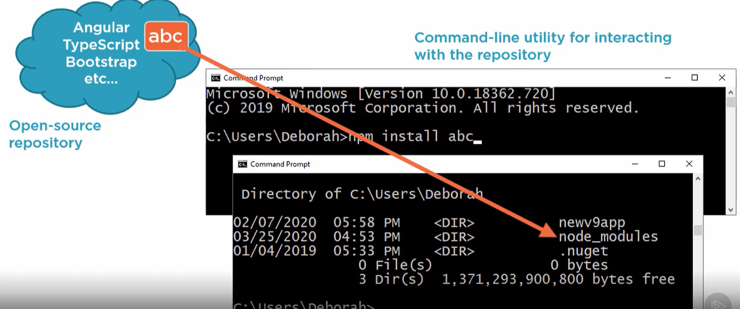

It can be thought as an **online registery** or repository for an open source for free library and packages. It contains many java script packages, such as angular, typescript and bootstrap which is a web styling framework.

Secondly it is a **command line utility** for interacting with that repository. We can type command such as **npm install abc**. NPM will locate that specified and install it on your local machine, in the subfolder of your current folder node\_modules folder.

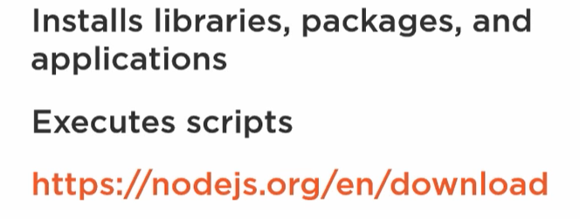

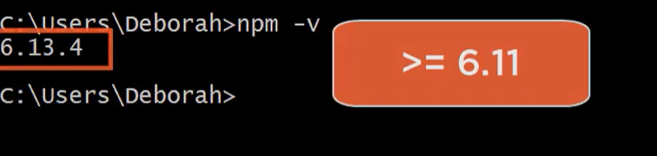

**Package.json**

In layman terms it is the first file your browser looks for, to find all the information of your web app.

It defines each package that is required for angular application. We then tell npm to use this package.json to define all the packages along with their dependencies.

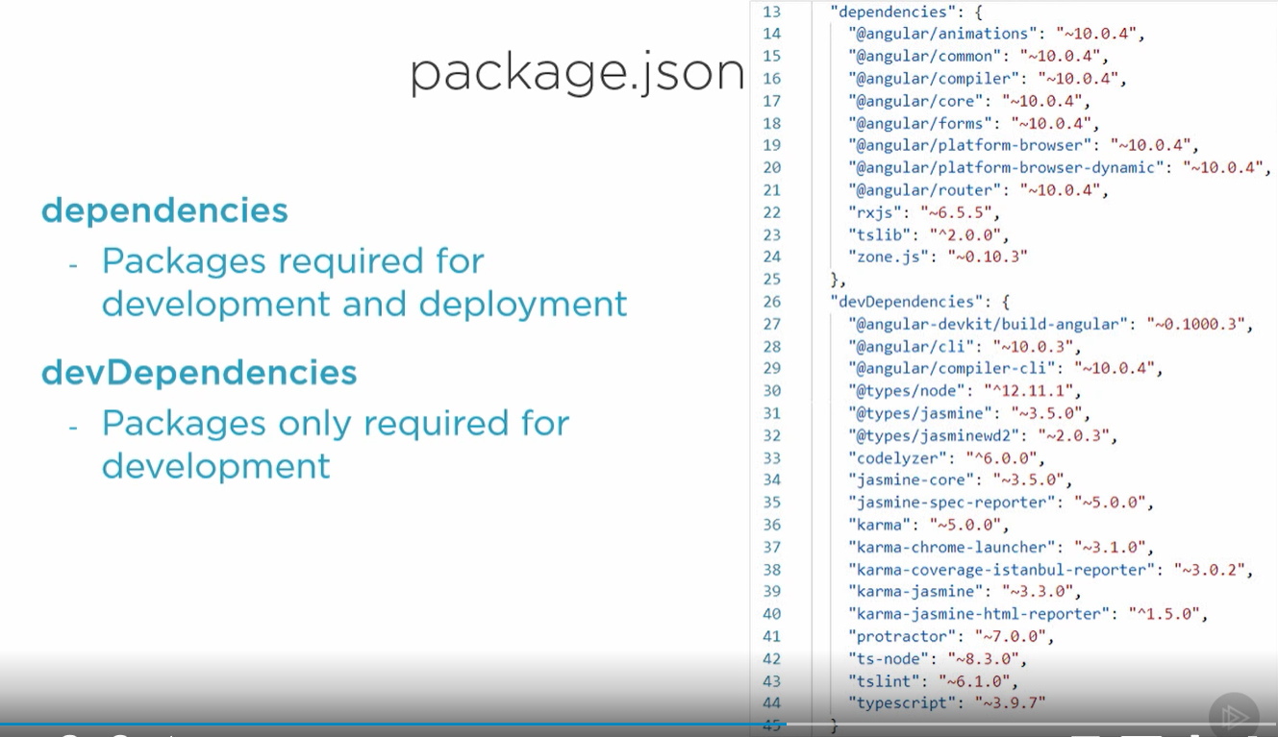

Modules

Java script, specifically ECMAScript (ES) 2015 uses the term Modules for the pieces when splitting up the java script programs. In ES 2015 a module is a file, and a file is a module. So, encoding in ES 2015 we don’t need to define a module, just create a file write some code, export or import something and bang the file becomes the module.

Angular leverages the ES 2015 Module. Angular has also it’s Angular Modules.

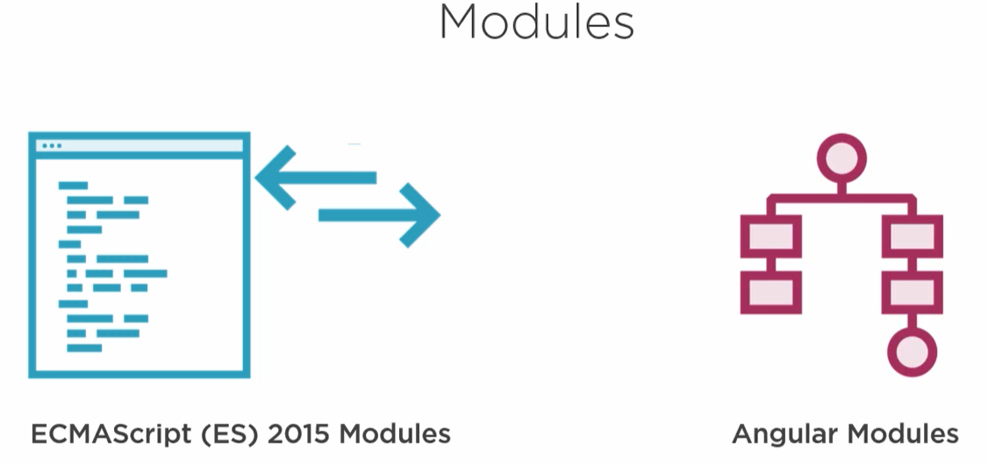

First let’s see how ES 2015 Modules work. Say we create a file call product.ts and export a class Product from that file, this file then becomes a module, because the class is exported, and we can use that class present in the file, in any other module or file( say product-list.ts) by importing it. The file product-list.ts also become a module because we imported the Product class.

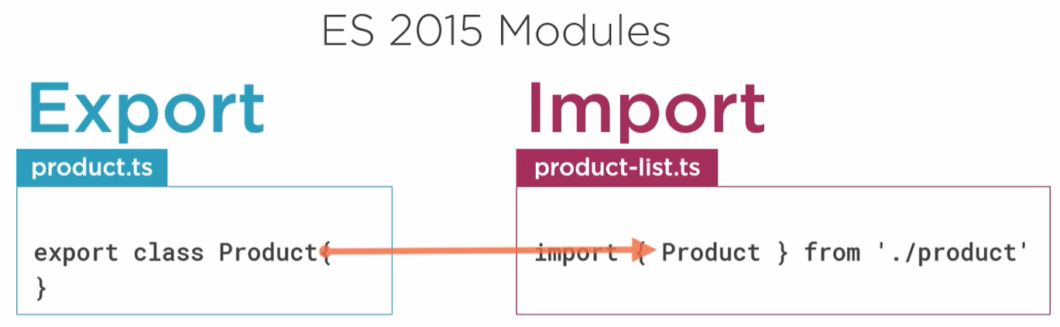

In this we have define the file 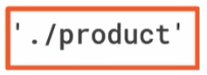from where we want to import the file, which is basically nothing but product.js. But wait we have not created any product.js file. Basically, when we compiled the product.ts file, this type script file got **transpiled** into product.js. So at the run time we are importing the Product class from product.js file.

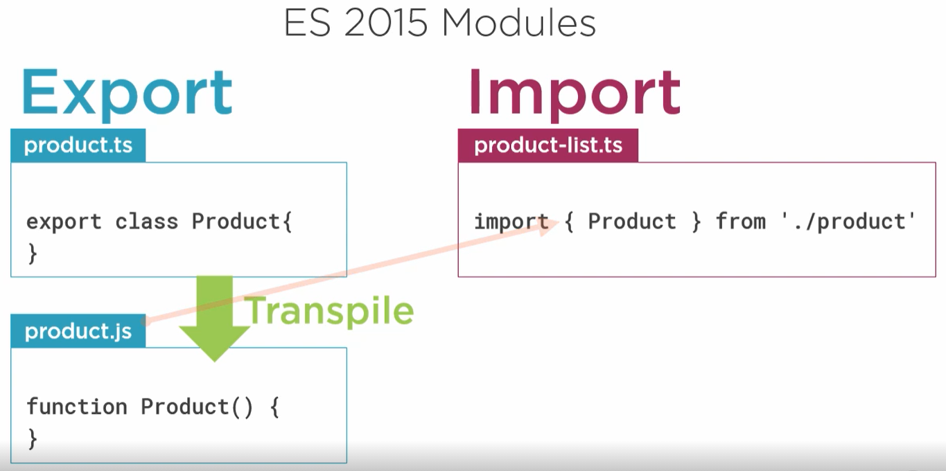

Every Angular application has at least one angular module, by convention called app module. As the application adds more features, we can group those features into its own angular feature modules. We can even define Shared module or common module for codes used by multiple modules. Each component created are only associated with one module.

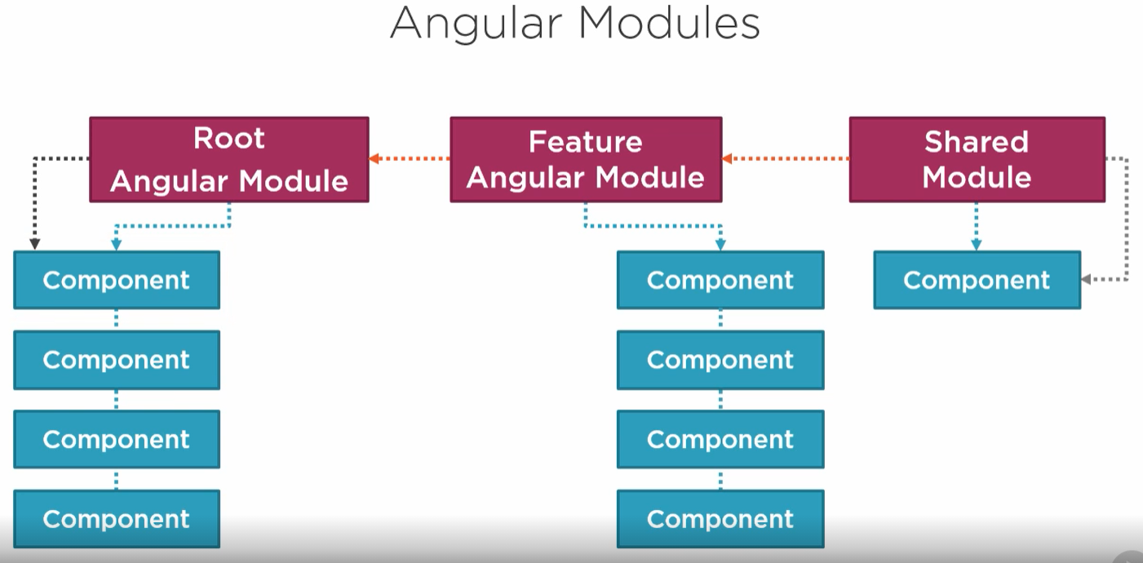

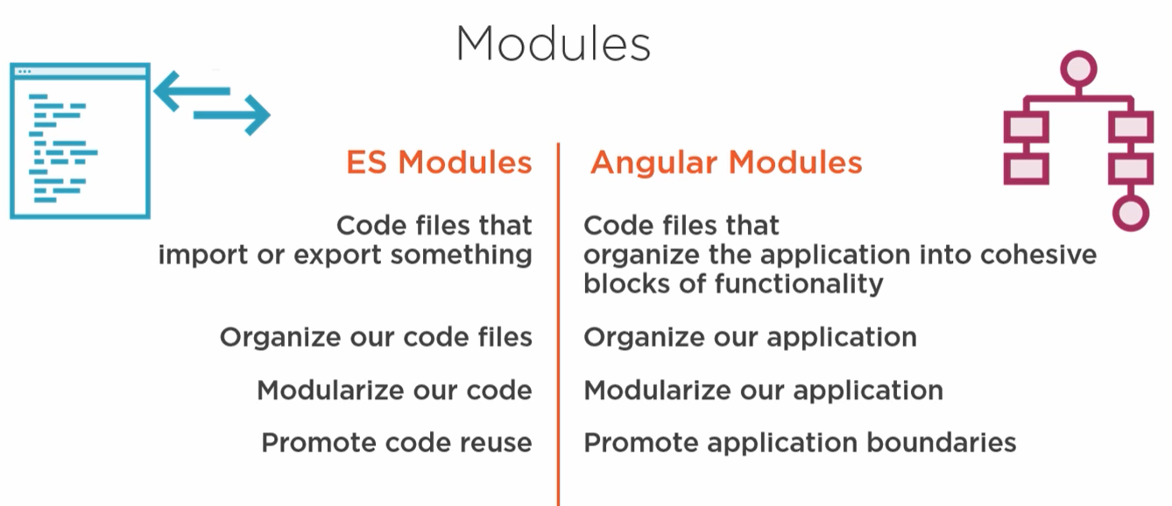

Component

A **component** is like a META-DATA.

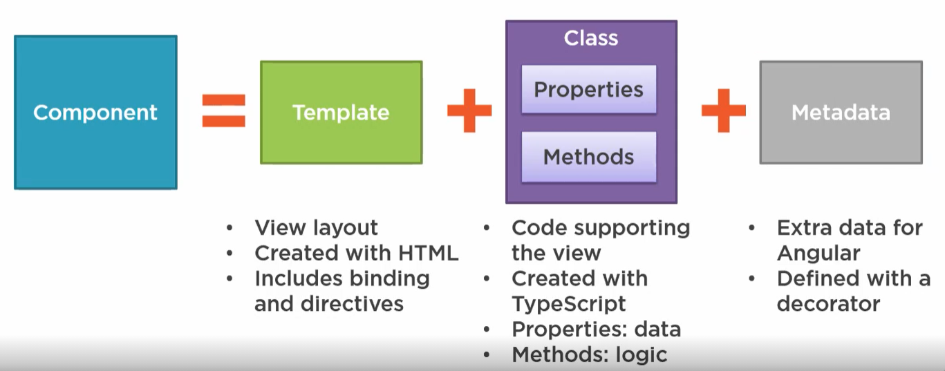

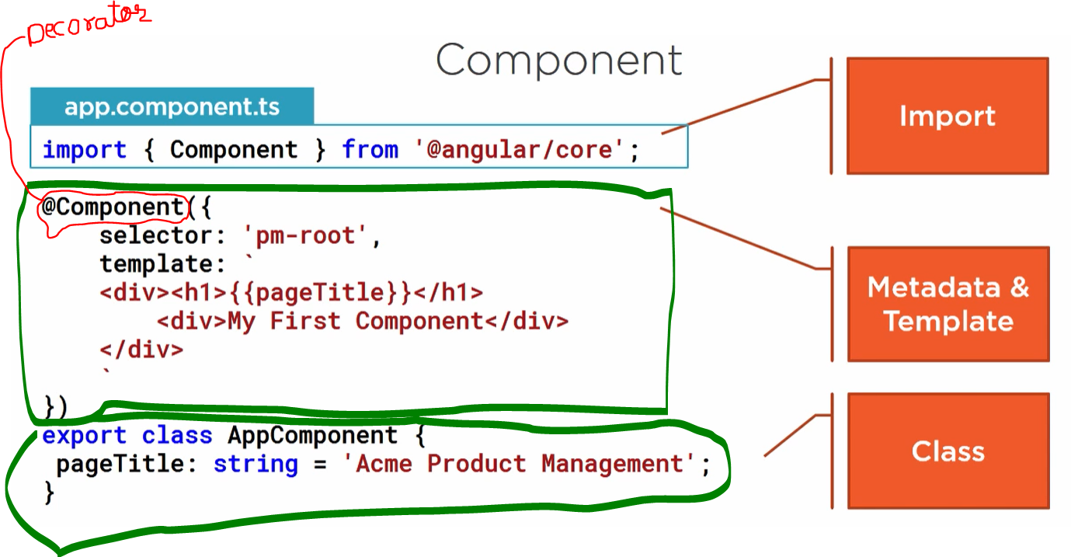

Angular need the metadata to understand how to instantiate the component, construct the view and interact with the component. We define the component metadata with angular component functions. In TypeScript we attach that function to the class as a decorator. A **Decorator** is nothing but a function that adds metadata to a class, its members or its method arguments. A Decorator is a java script language feature that is implemented in TypeScript. The scope of the Decorator is limited to the feature that it decorates. Decorator is always prefixed with **@** sign. Angular has several builds in decorators to provide additional information to the angular. We can also create our own Decorator. We define decorator immediately above the class signature.

Since a Decorator is a function, there we always add a parenthesis.

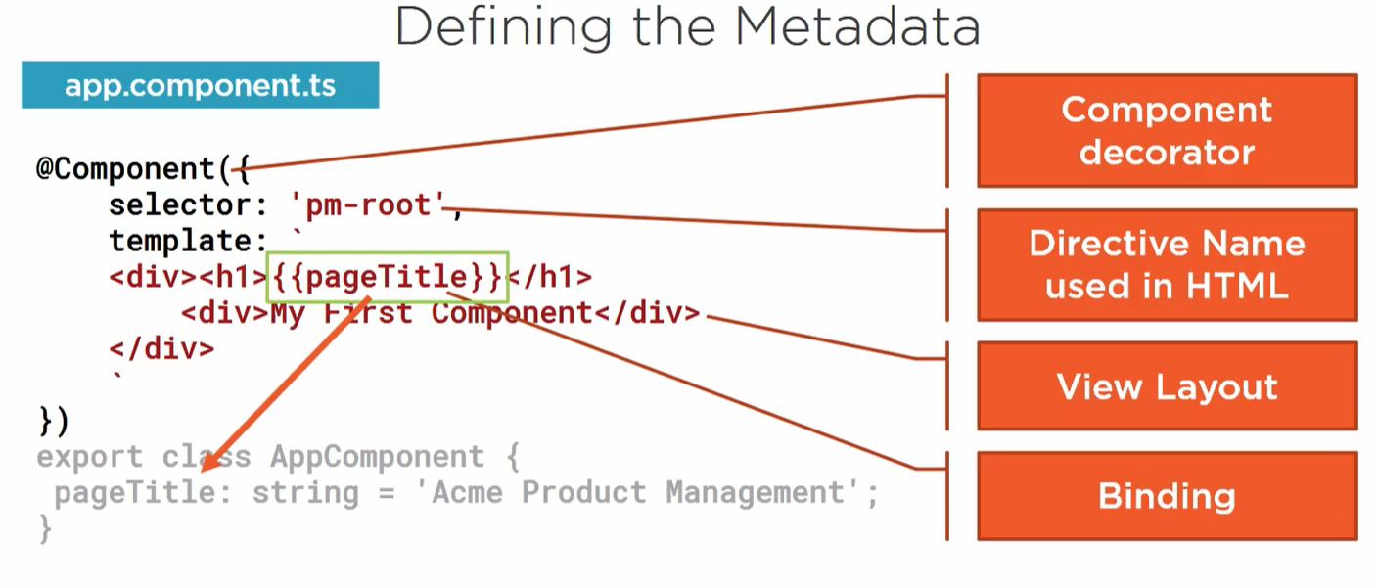

Every component can be assigned a tag or a selector, which is basically how somebody can use the component. A component should always have a template. Assign a name or selector to the component so that it can be used. For example: this selector(**pm-root**) is the one which consumer will be using to call and render the header component. This selector can now be used in any html code like <pm-root></pm-root>. When we use this selector(**pm-root**) any where on the html, then this pm-root can be referred as **directives**. Directives can be thought of as a custom html tag.

**Note:** If the component is not going to be used in any html for rendering the view, in that case we don’t need to define the selector tag in the component decorator.

What are **Directives**? At a high level, **directives** are markers on a DOM element (such as an attribute, element name, comment or CSS class) that tell AngularJS's **HTML** compiler ( $compile ) to attach a specified behavior to that DOM element (e.g. via event listeners), or even to transform the DOM element and its children.

Component = selector + template + style and other properties, using which it specifies the metadata required to process the **component**. It is the Metadata that identifies this class as an angular component. So, a component is a view defined with template.

Syntax: ng generate component <name>

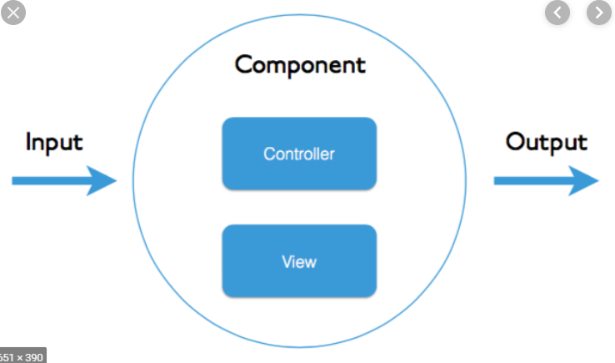

A **Module** is like a Container. It is a container for components and services. To be more precise it is a group of logically related components. When you build an application, you just don’t build one module otherwise it can drive crazy, so we would like to organize your code, so you would like to build feature modules, which are basically a group of related components.

Syntax: ng generate module <name>

An **Angular Service**. The annotation **@Injectable** tells angular that this is a service. Service is never tied to any component or module so that they can be used by anyone.

A **Dependency Injection**. There is no annotation for this. In order to allow angular to give us the instance of the service, the convention is to create an argument to the constructor, which is of that type is a container for components and services. To be more precise our component will have a class. We can use the constructor of this class to have service (web service) argument formal parameter passed to it. Now when angular cli will be loading the angular app, it will scan all the files. While scanning it will see, there is a **selector** text inside the @Component annotation present inside our component. When angular cli comes across this selector tag, it understands that when it will instantiate this component, then it will have to take care of the parameters that are passed to the constructor of the component class. Therefor angular cli will make the instance/instances available to this component.

**Dependency Injection Context**. Services are not restricted to the module, that they are provided in, that they are declared in. In the case of component, it is only available within the module. But in the case of service or providers, Angular creates a common shared space for services. There is this common area that contain all this service in your application that anybody can add to. You have ten different modules, each of those modules can have its own providers, those providers are not restricted to those modules, they become a part of this common shared service space and any other component that makes dependency injection and declares dependency on any of those services is going to get the instance of that service. This shared space is referred to as dependency injection context.

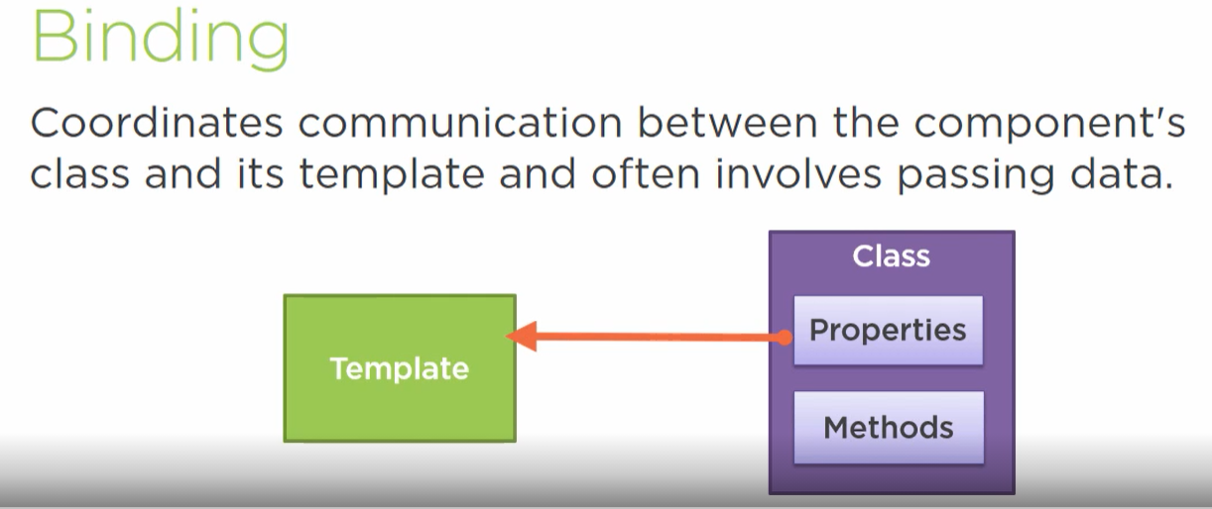

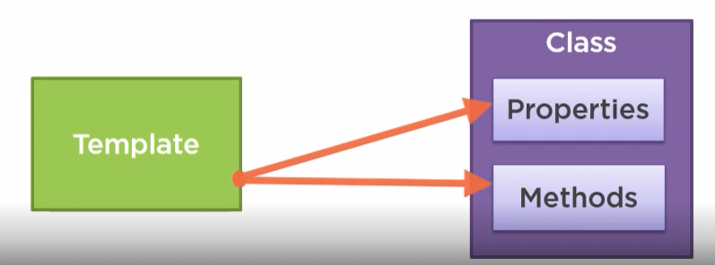

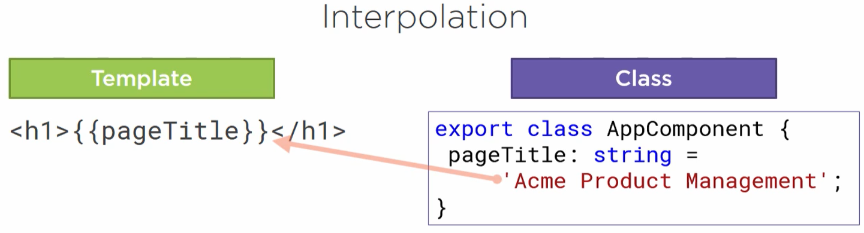

Interpolation is a one-way binding from class property to the template.

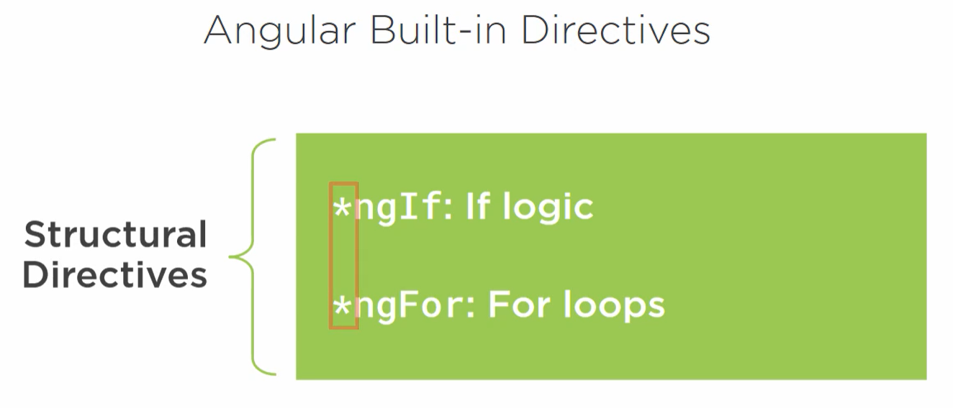

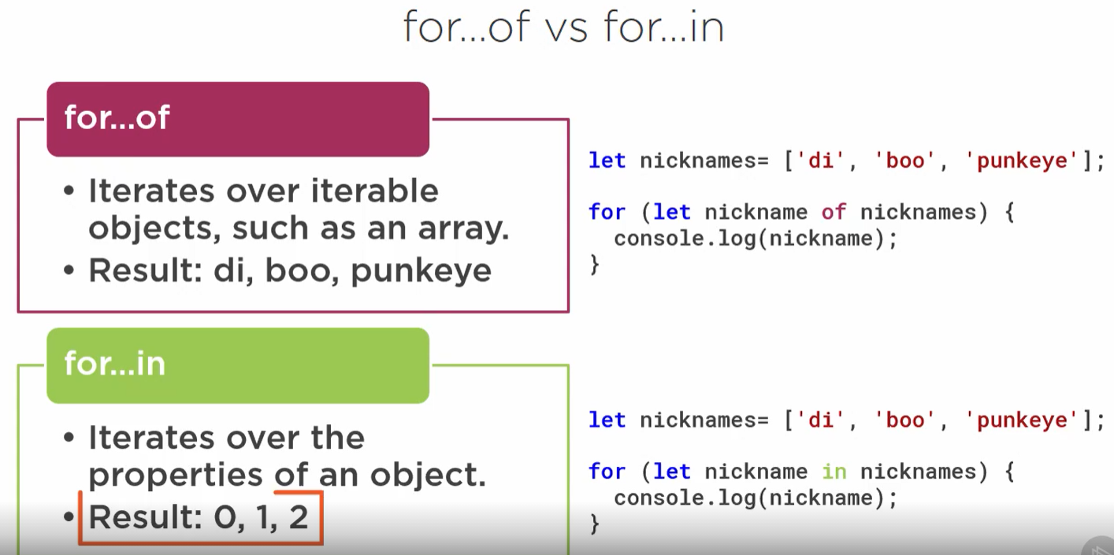

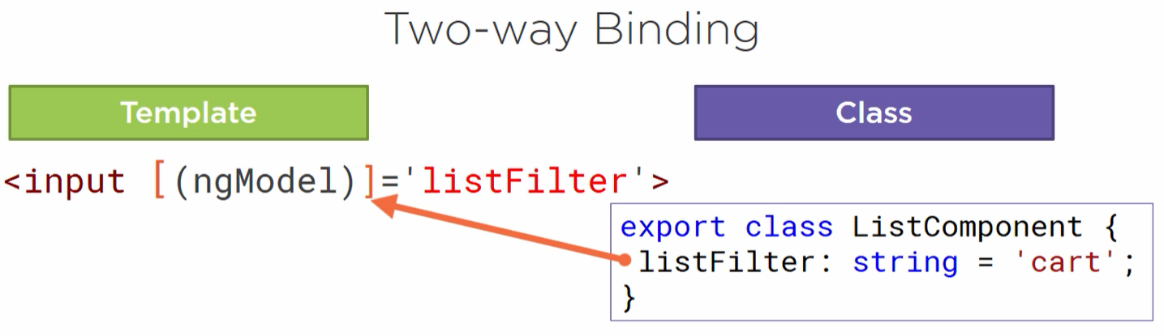

**[]** bracket is used for property binding, which means from the class property to the input element.

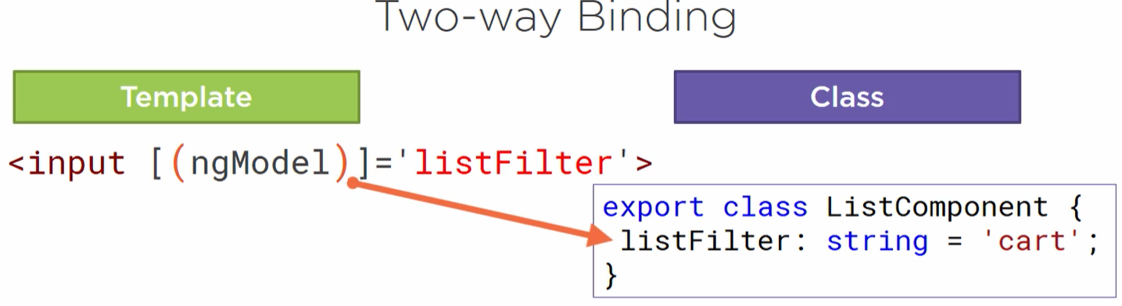

**()** to indicate the even binding, to send a notification of the user entered data back to the class property.

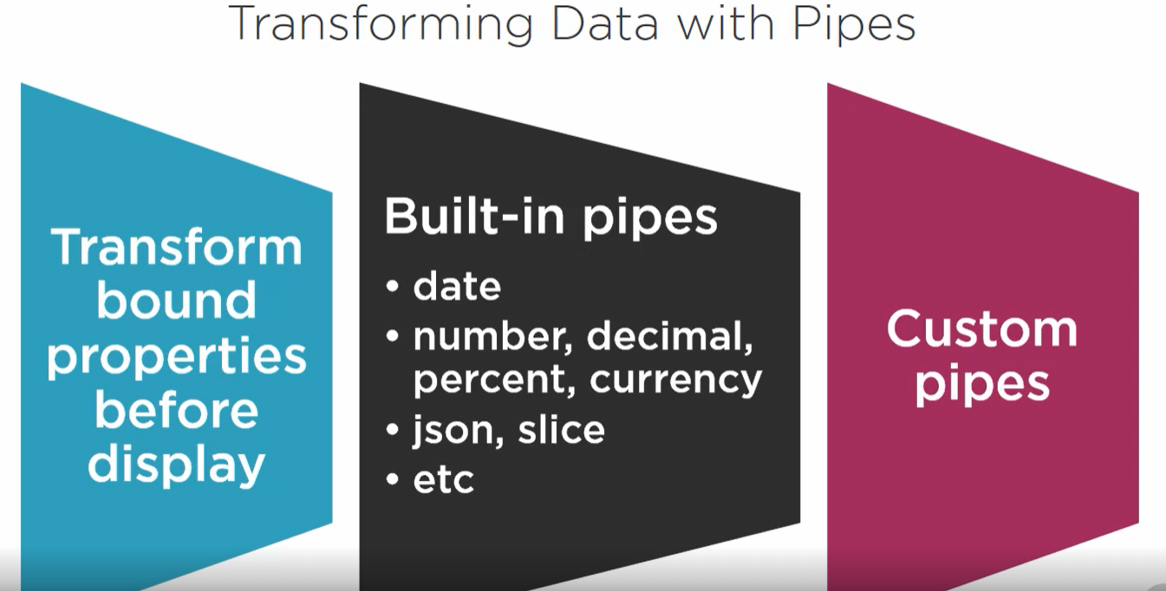

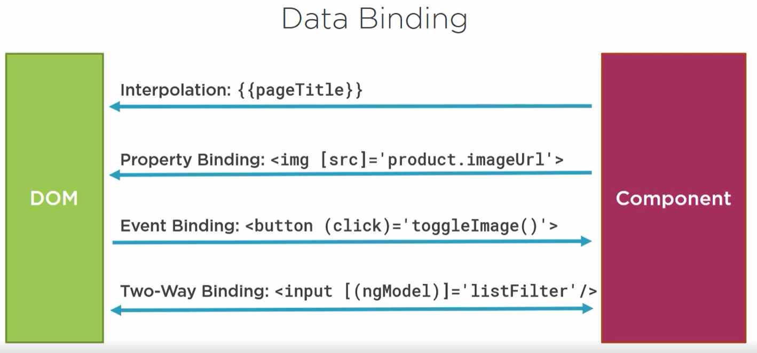

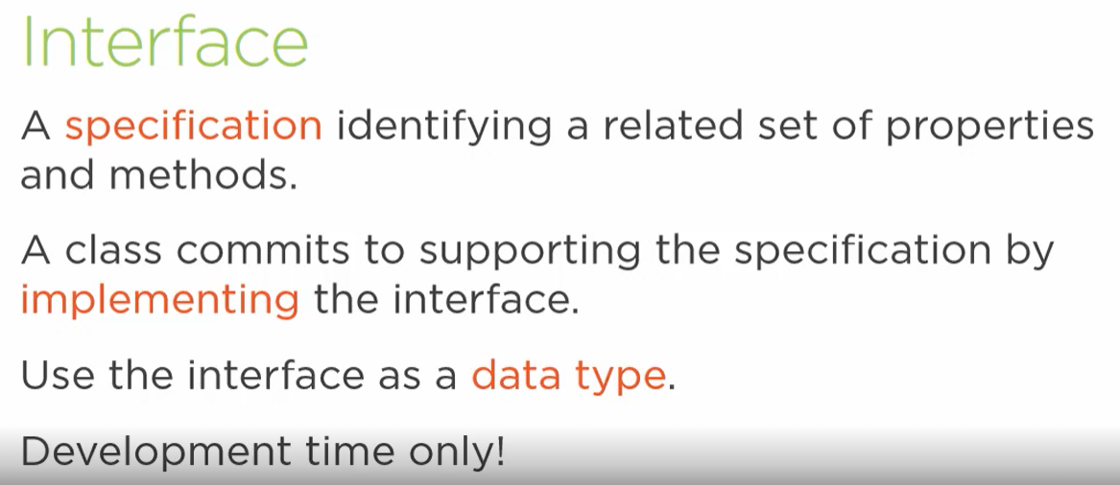

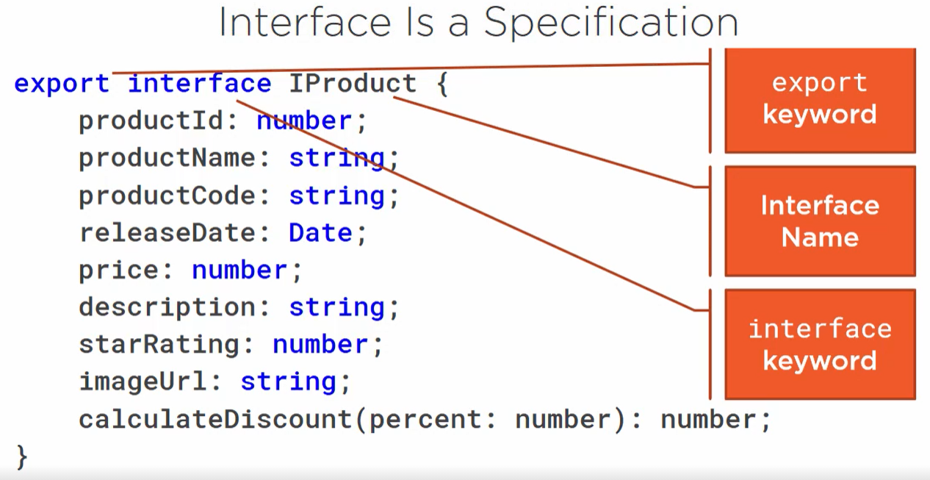

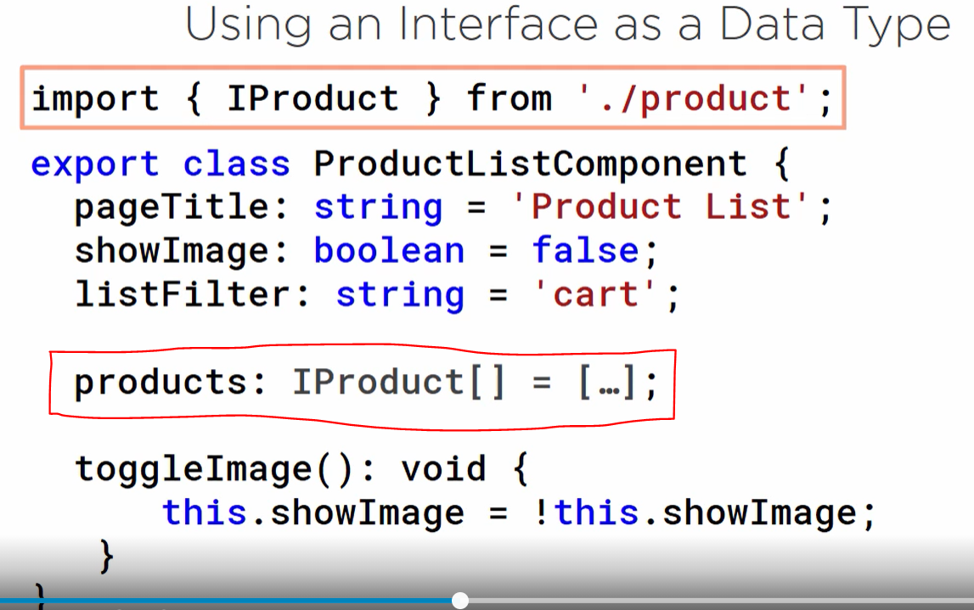

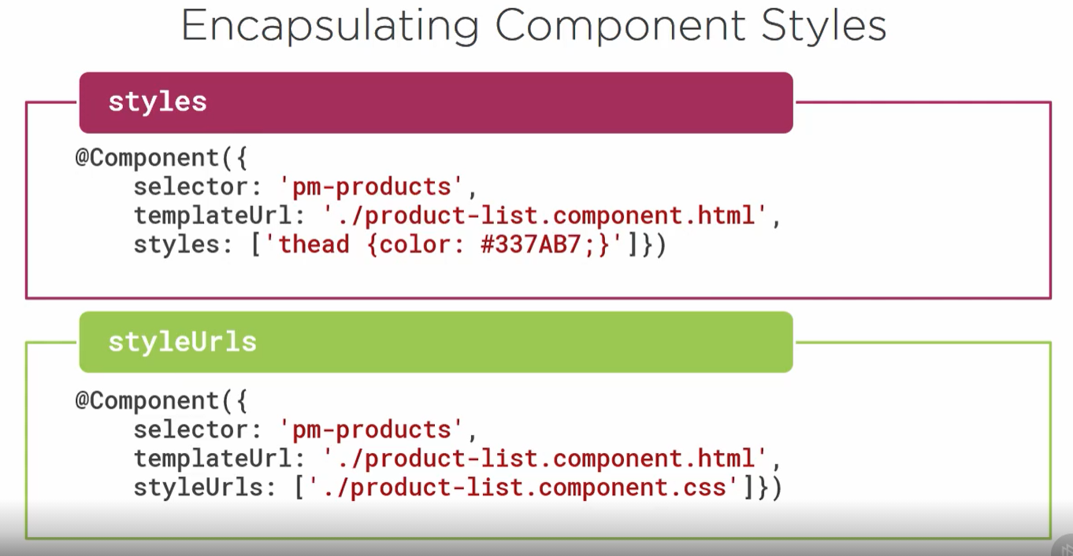

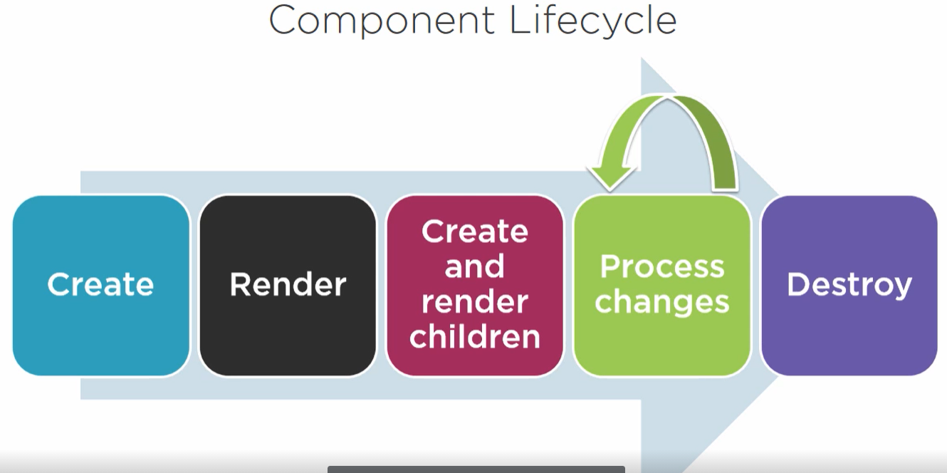

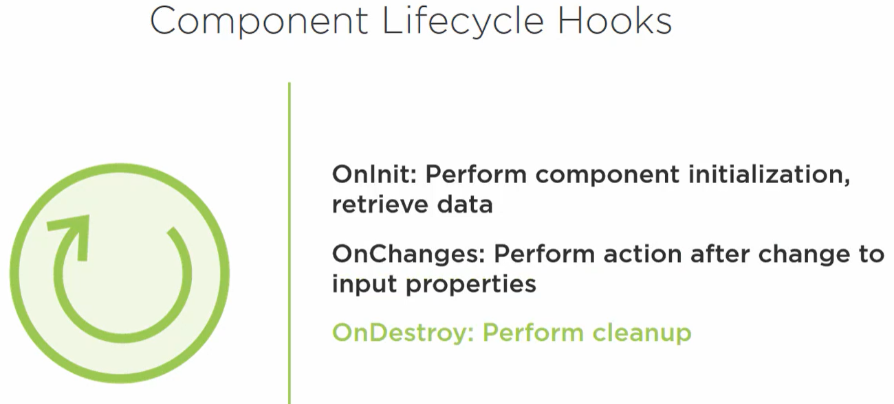

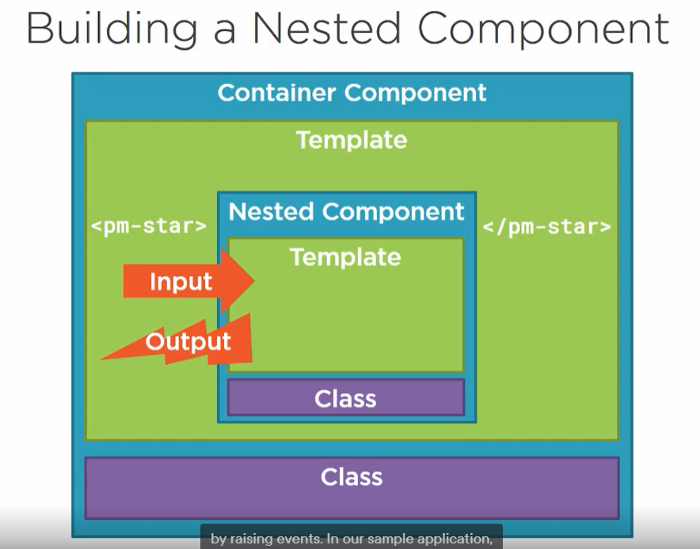

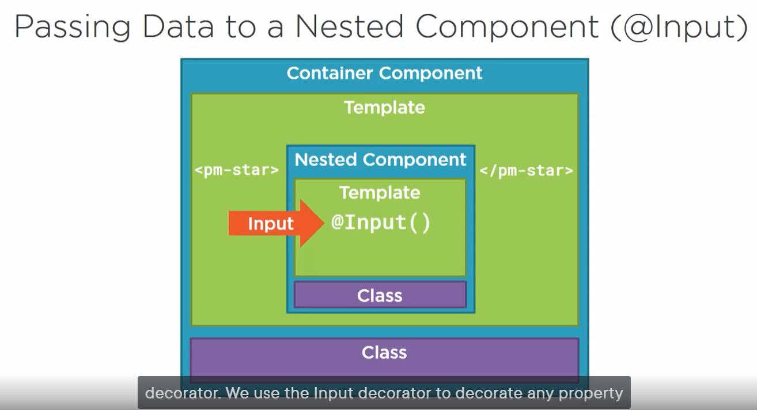

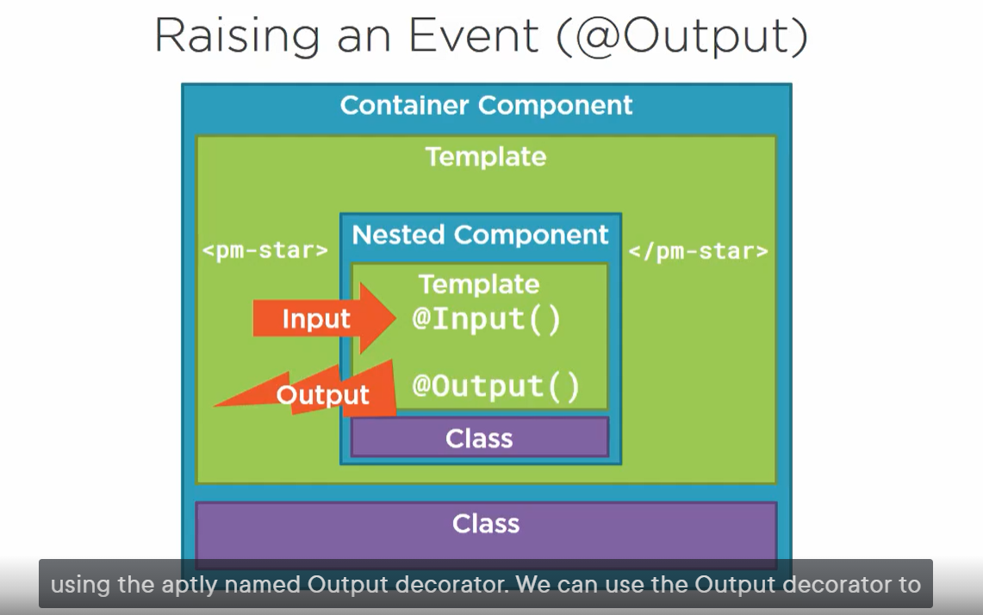

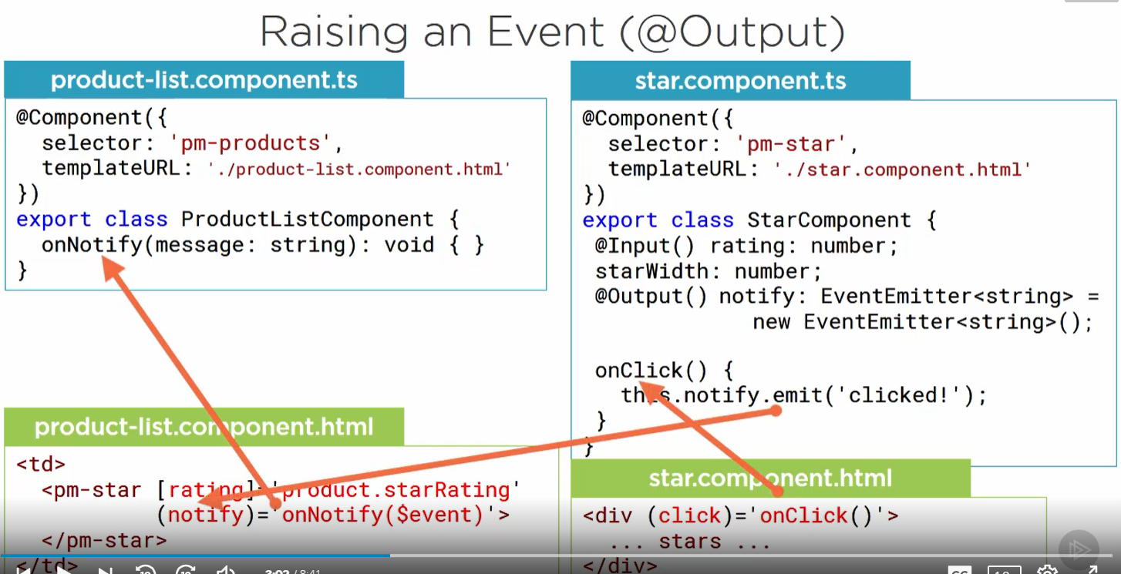

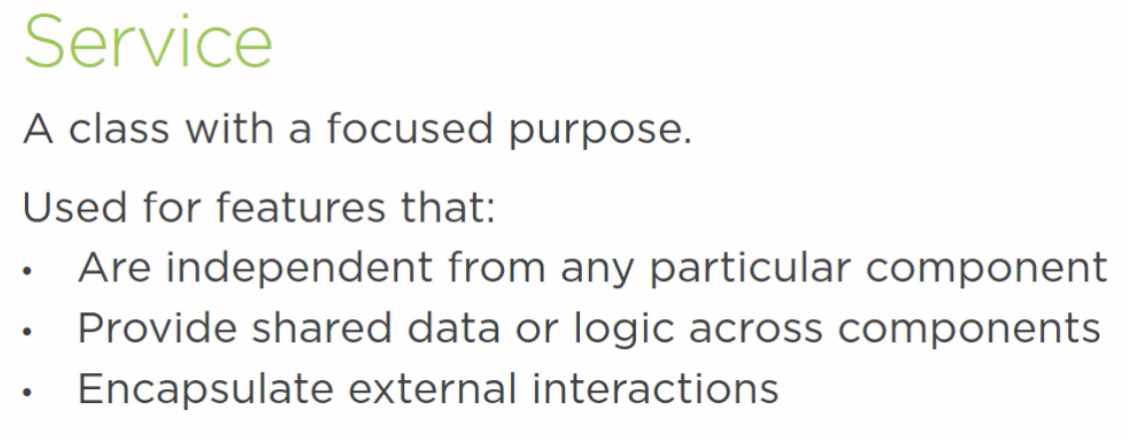

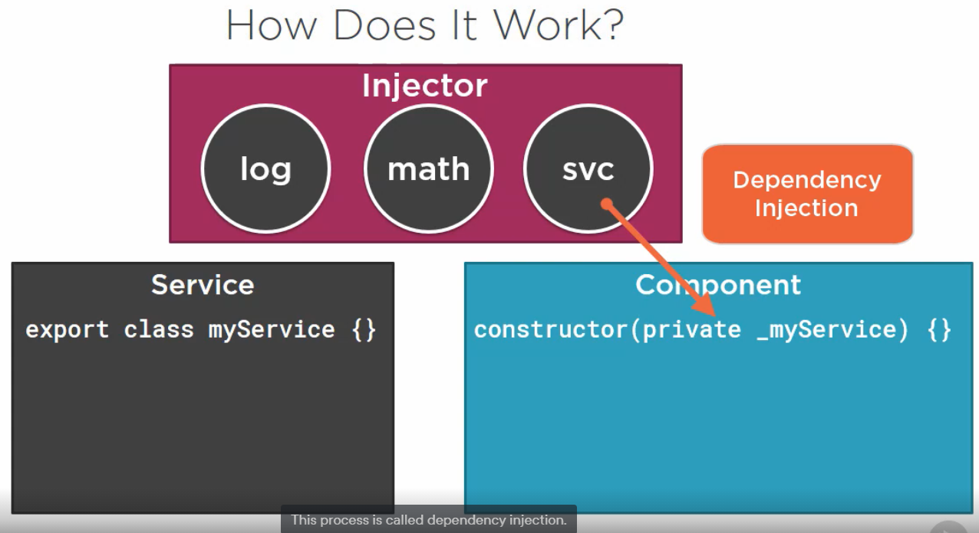

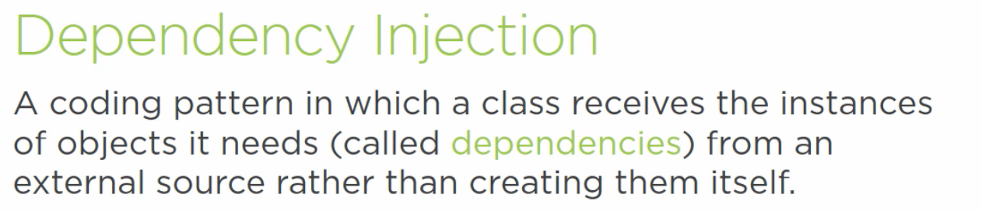

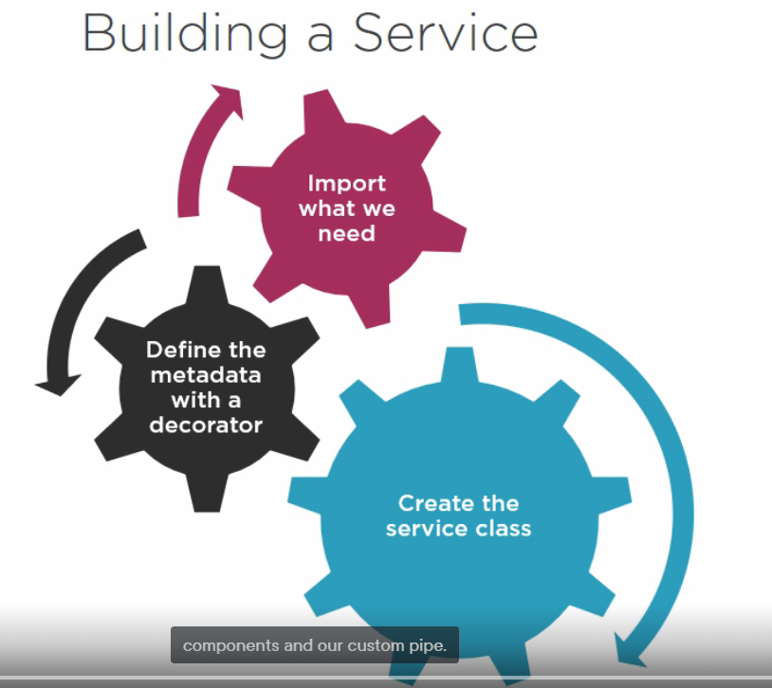

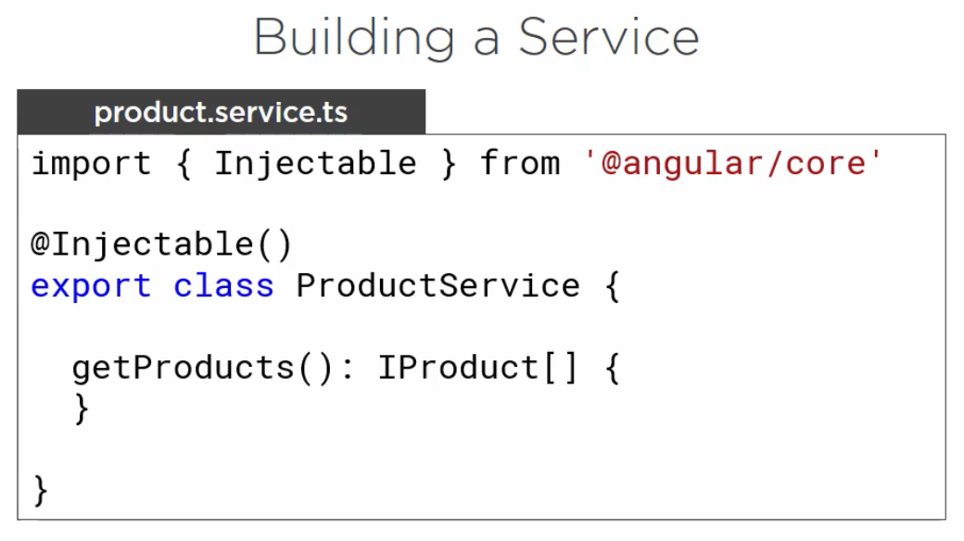

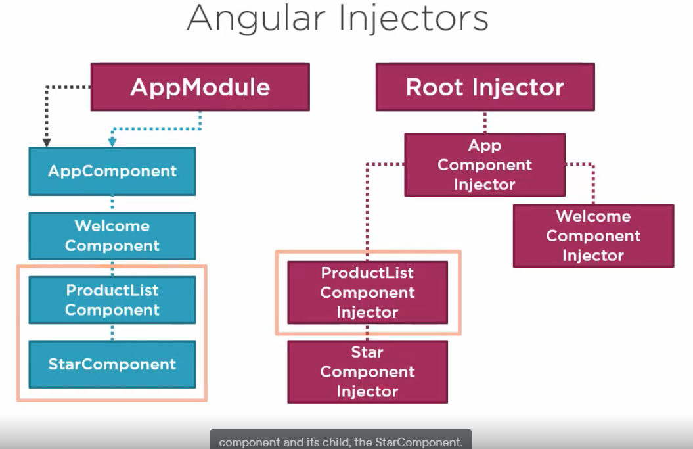

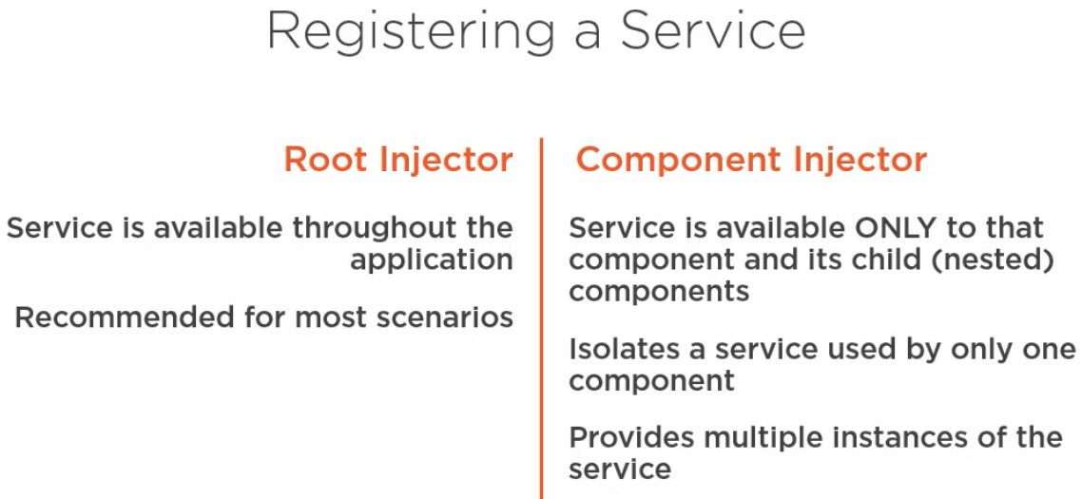

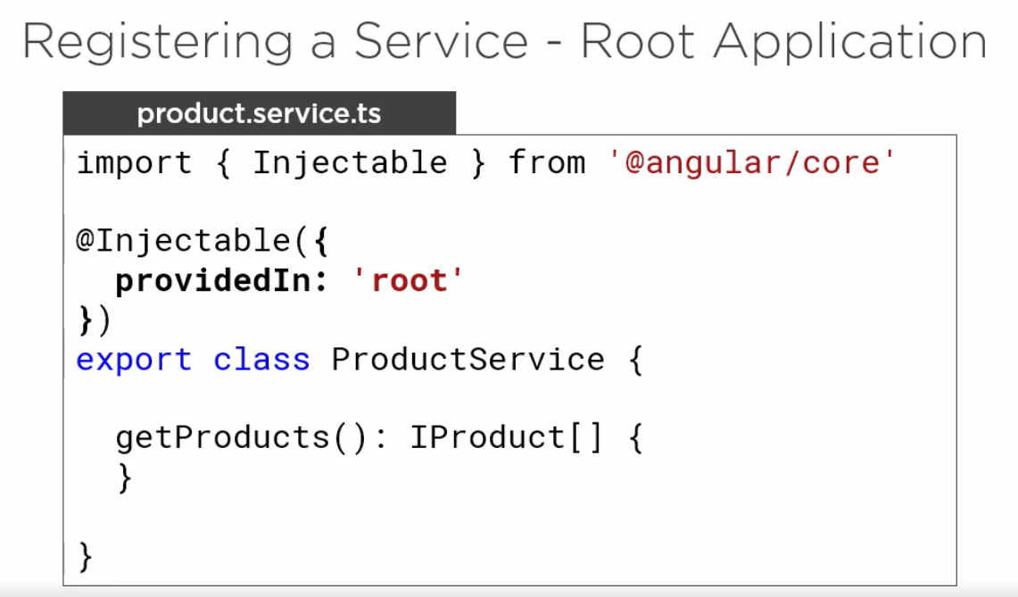

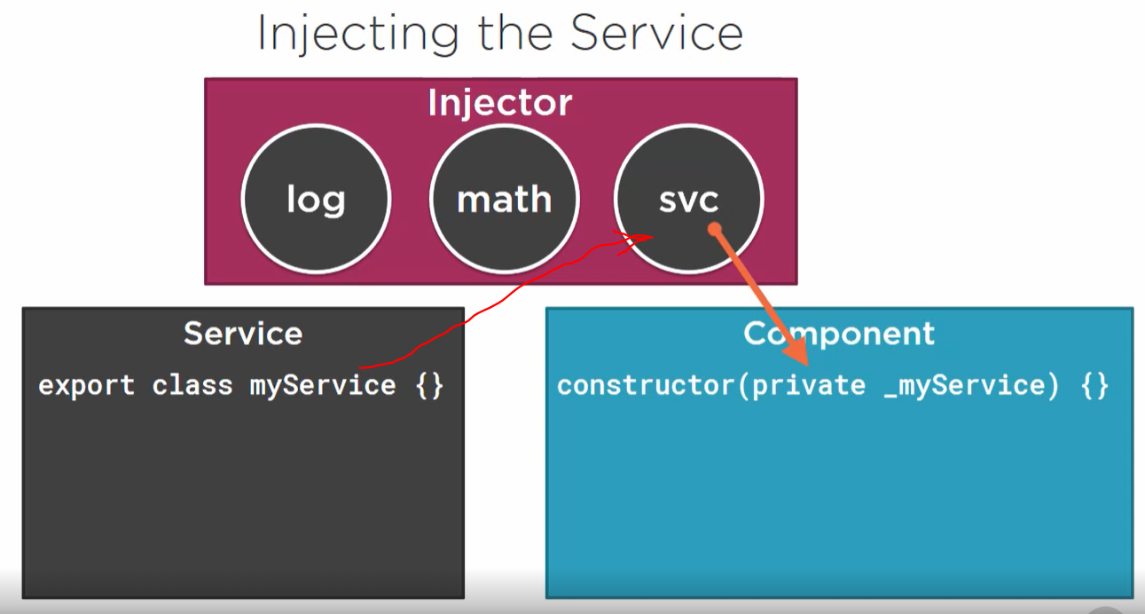

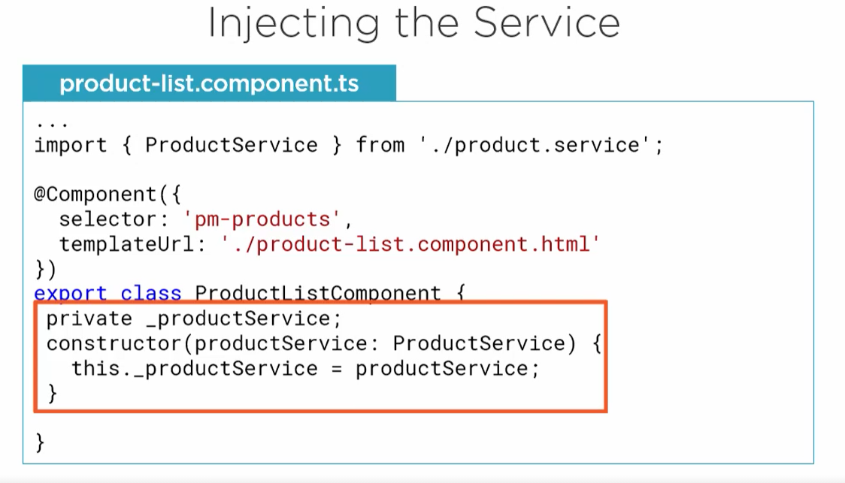

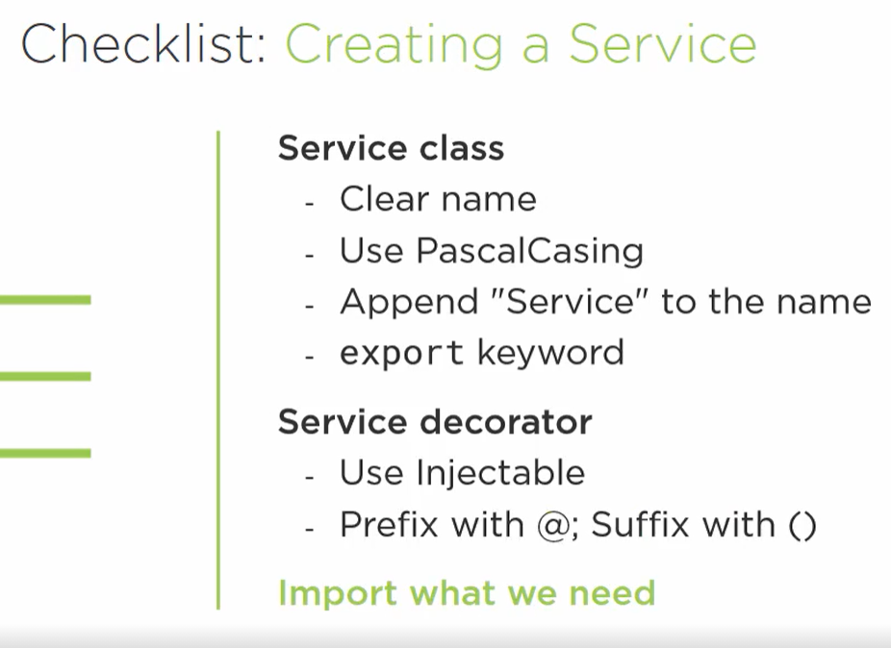

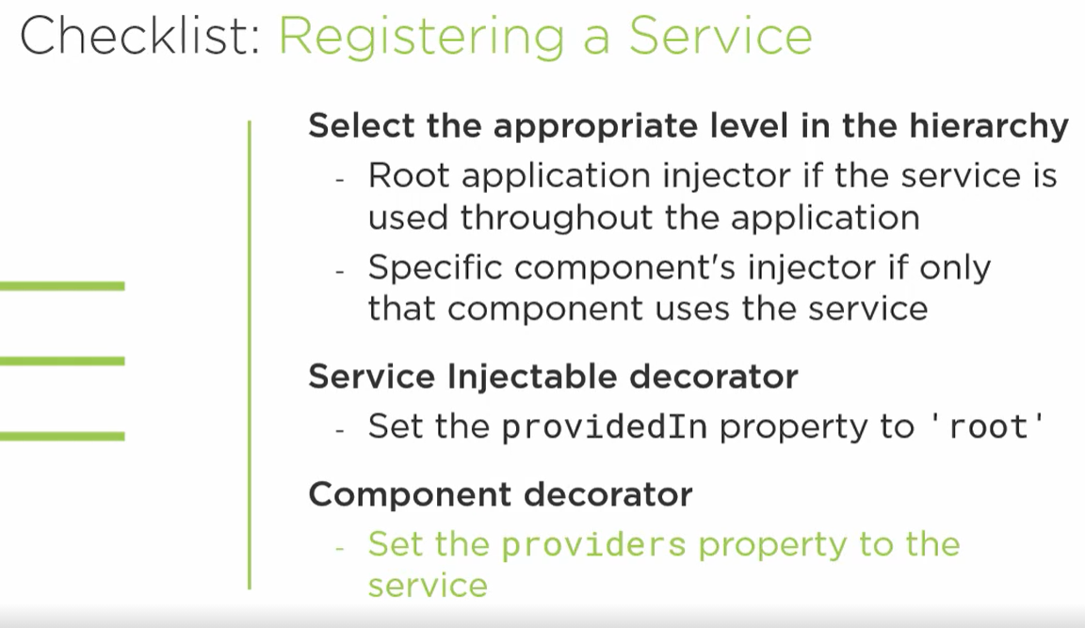

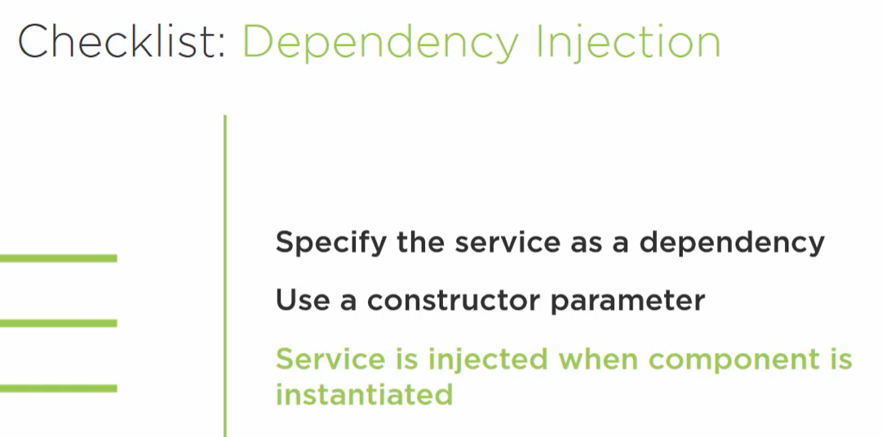

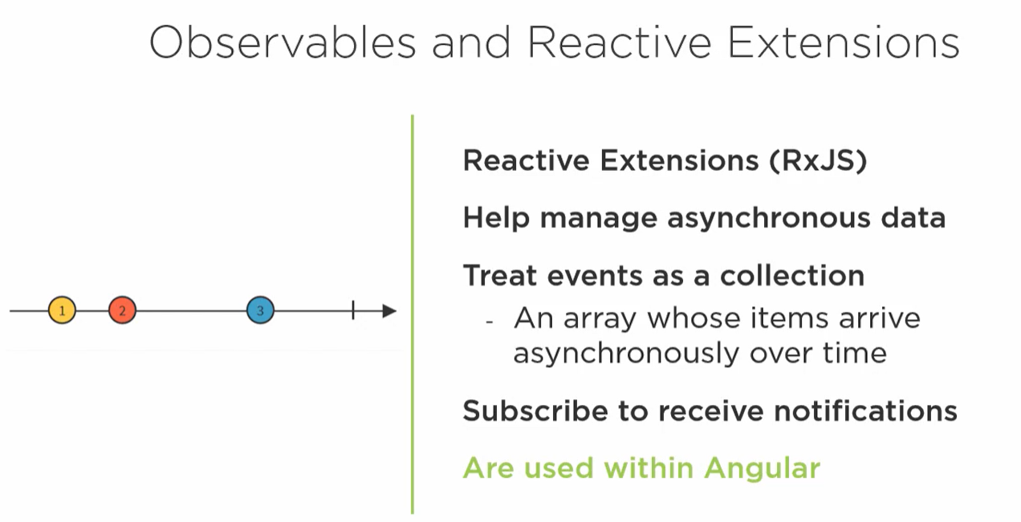

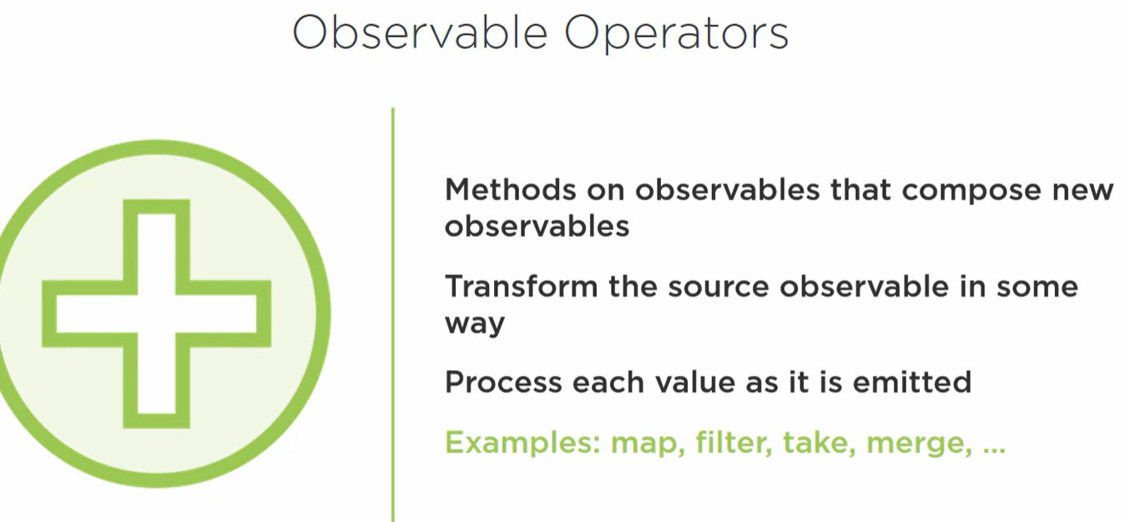

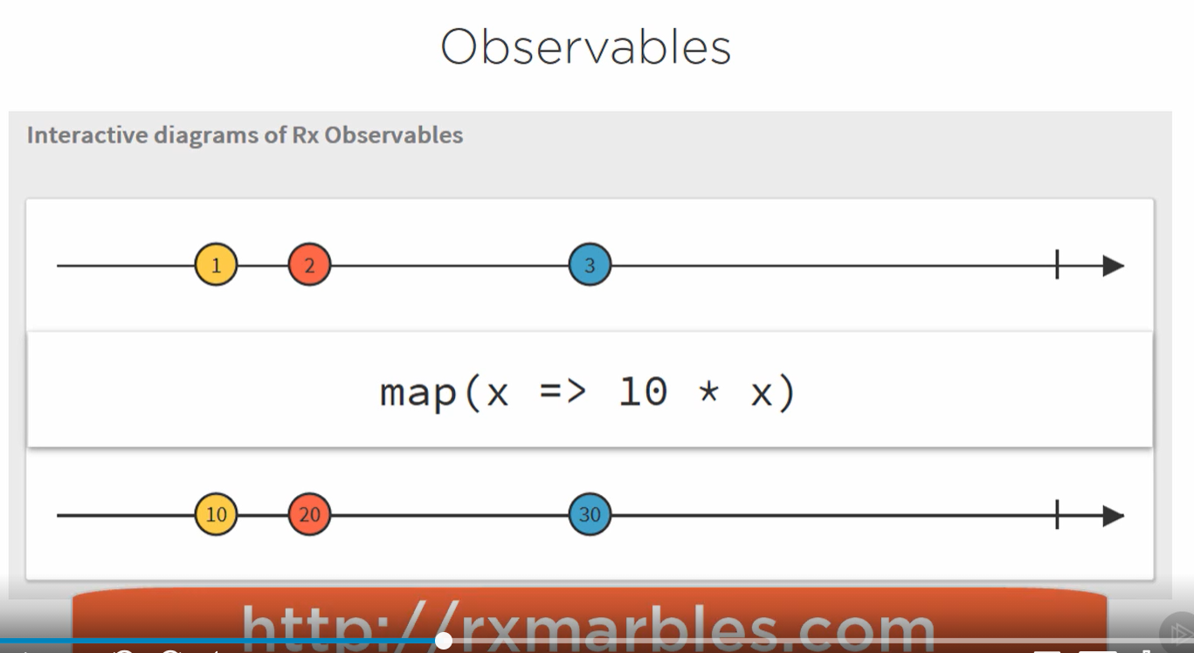

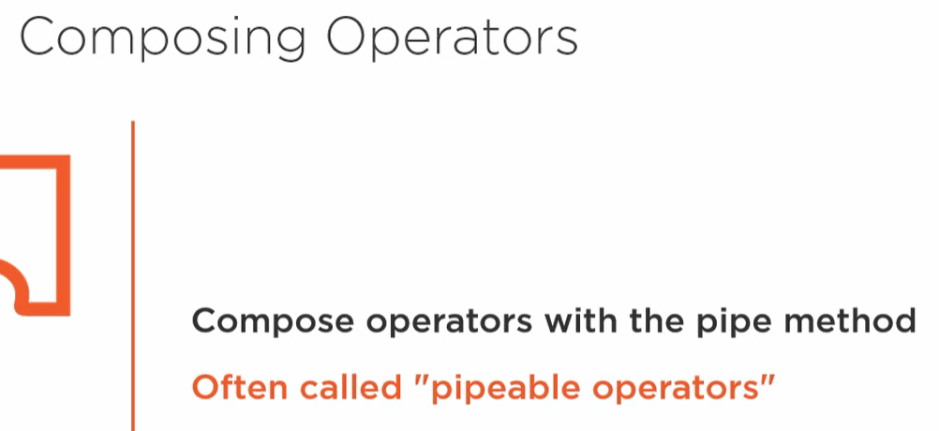

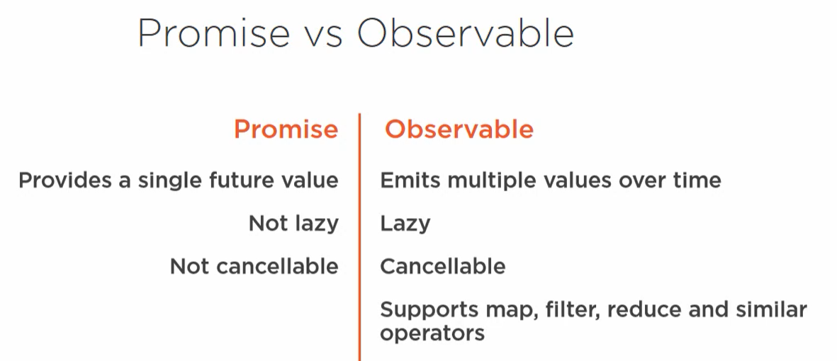

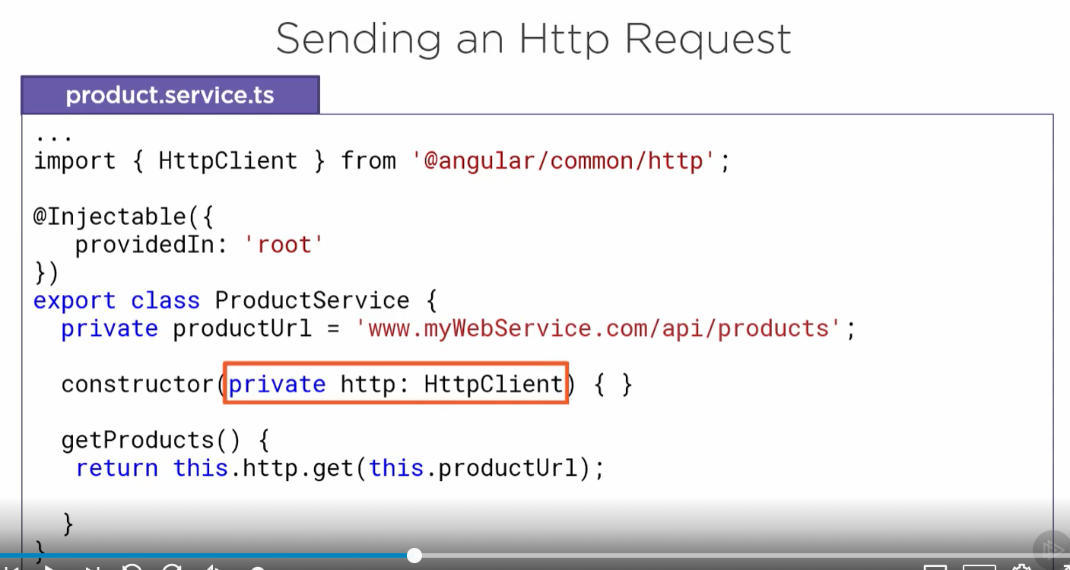

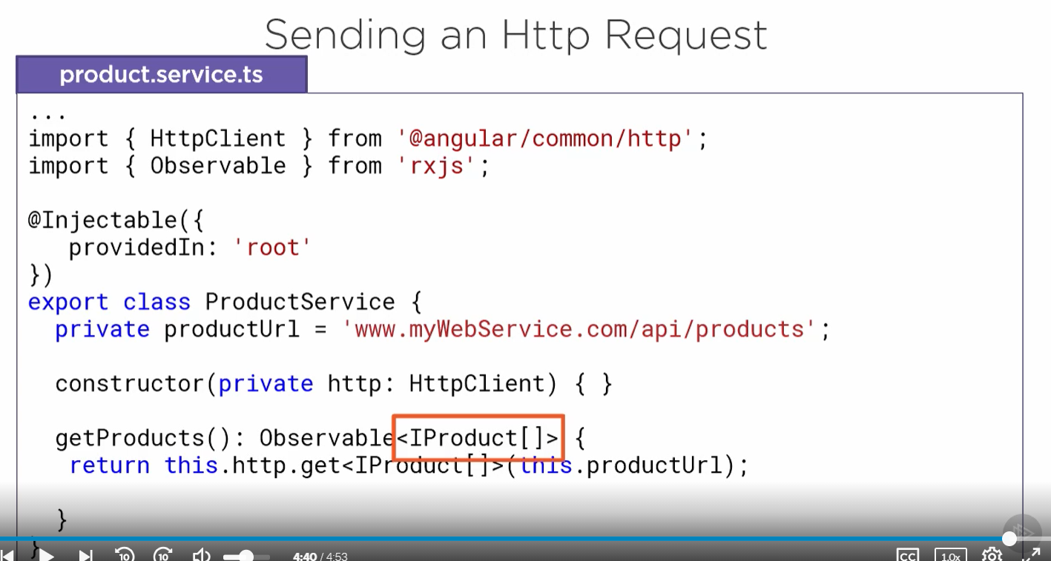

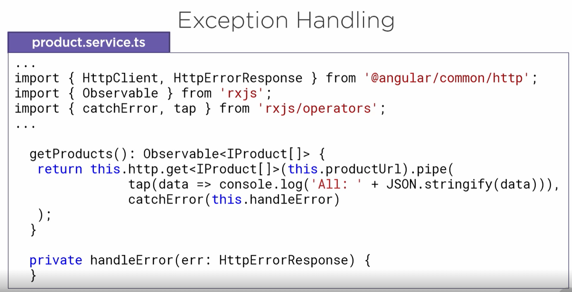

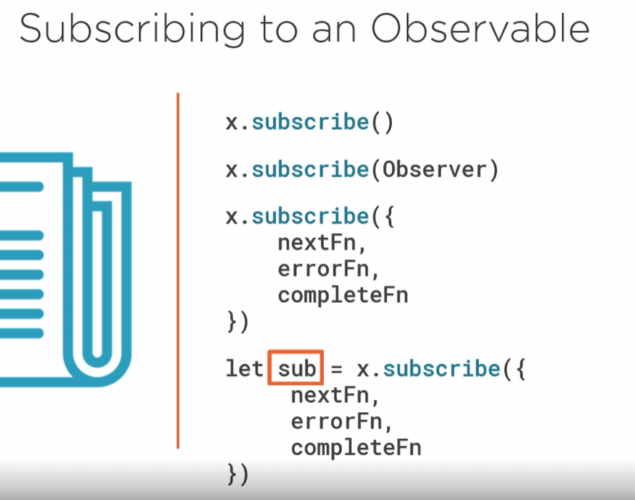

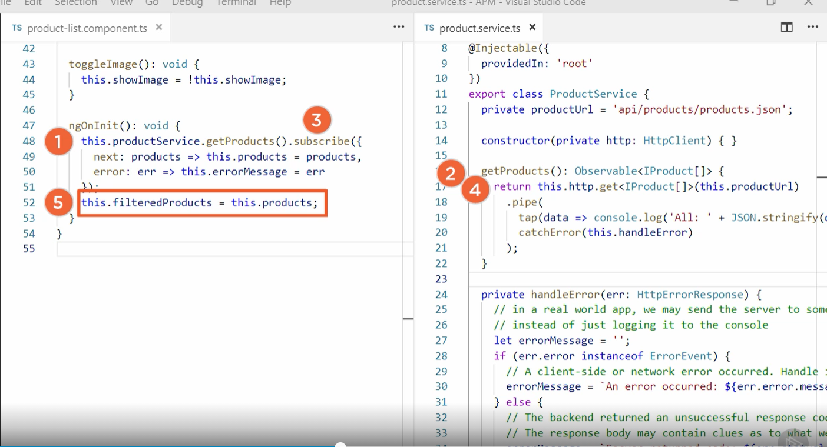

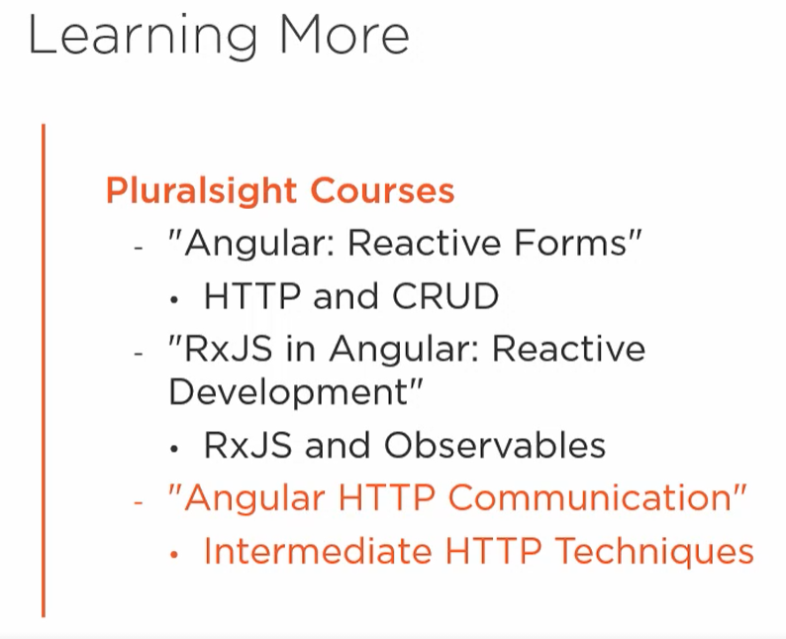

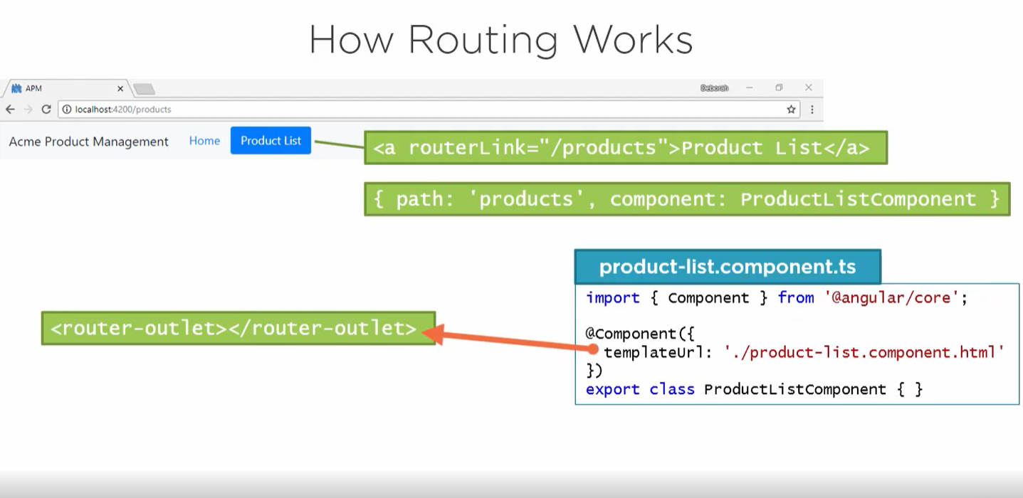

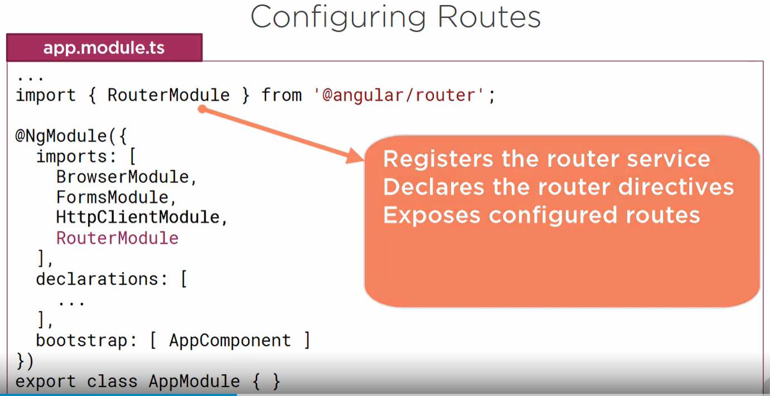

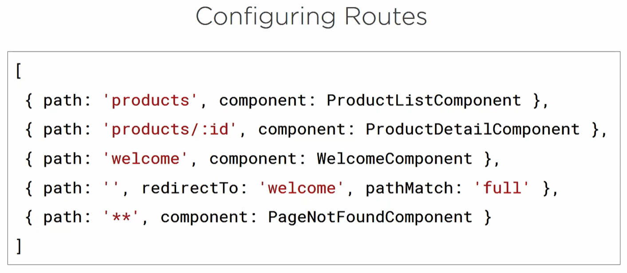

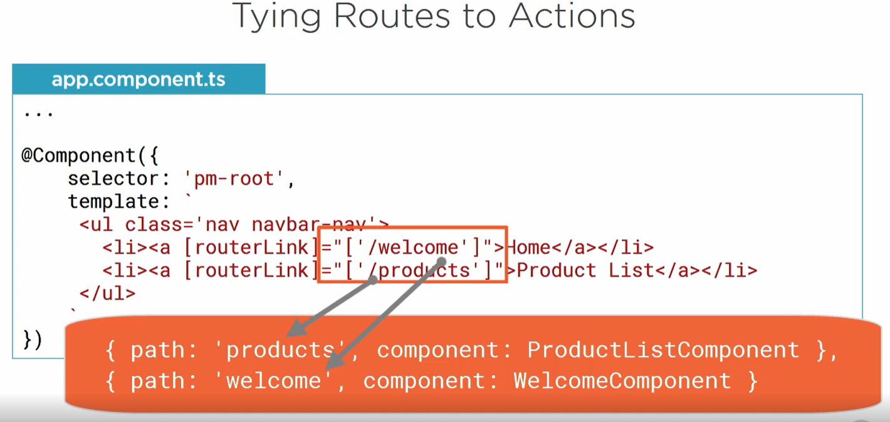

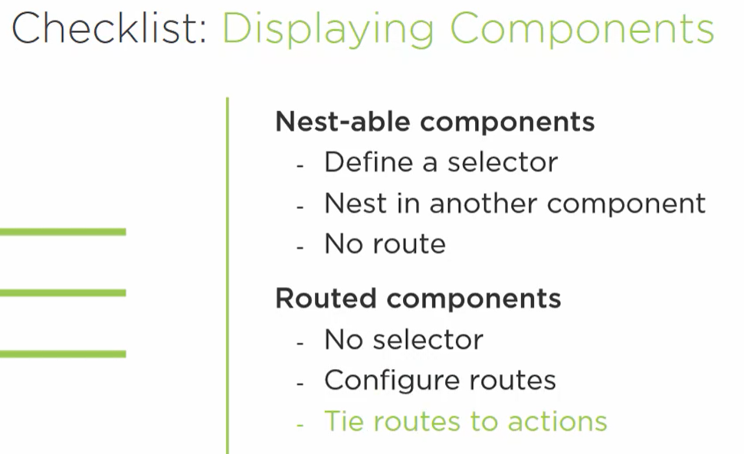

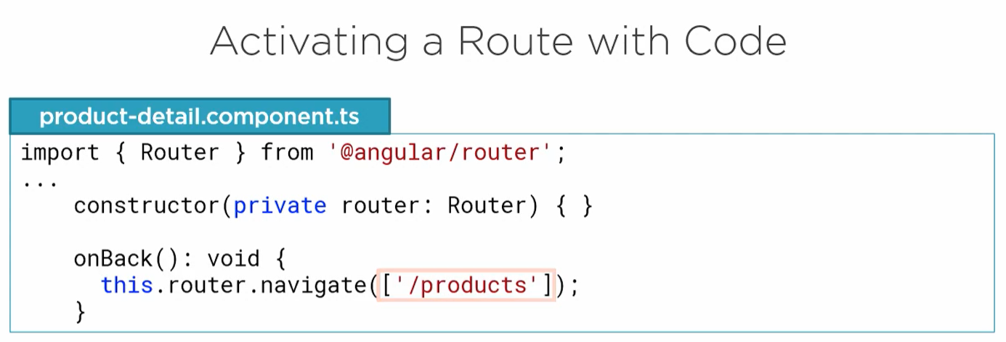

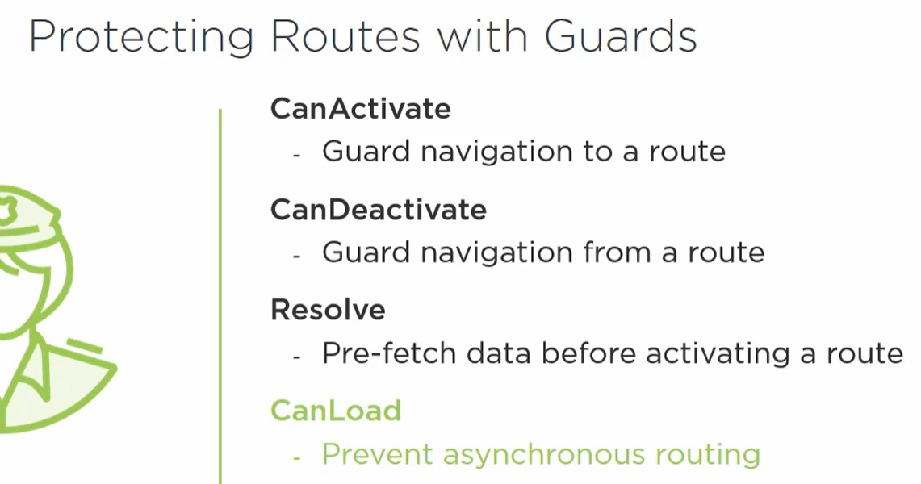

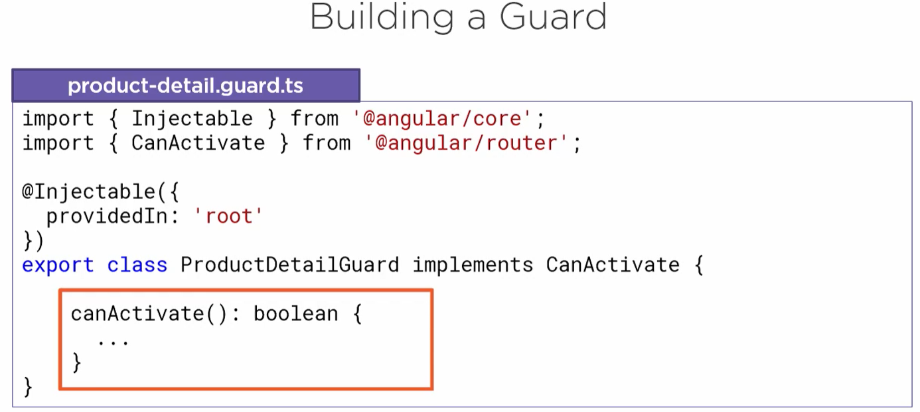

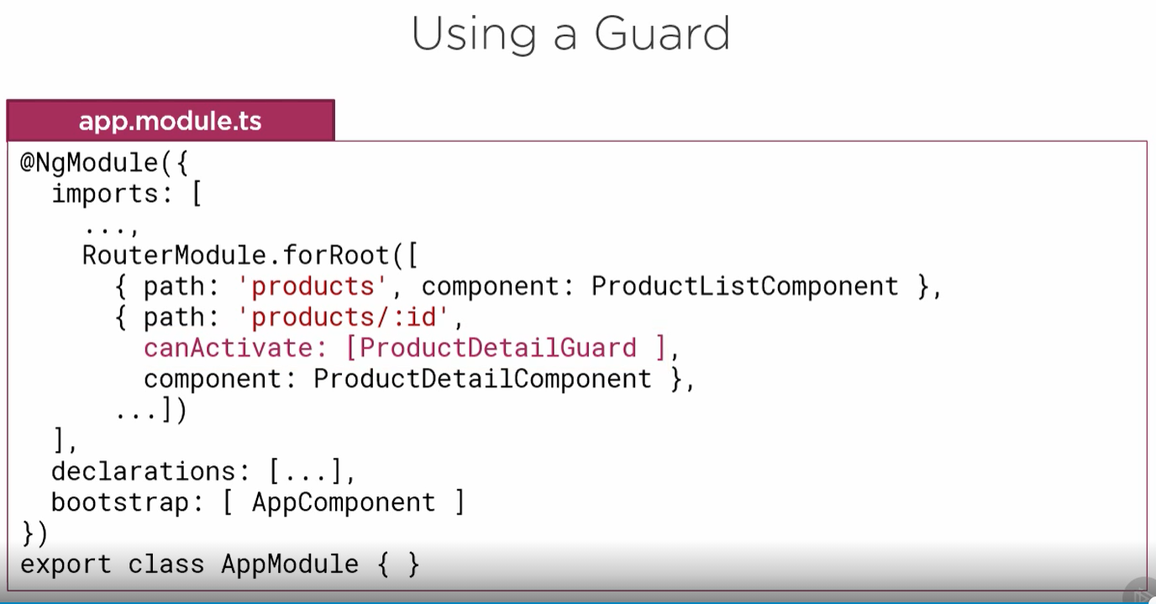

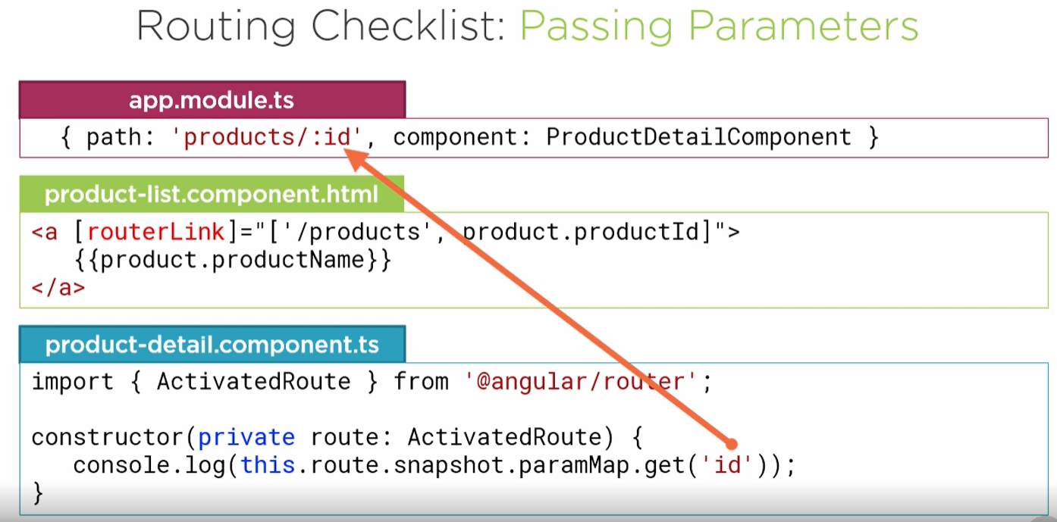

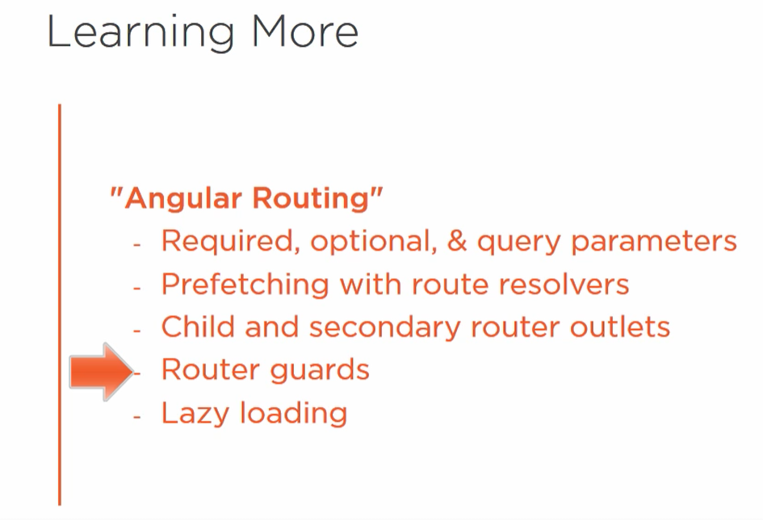

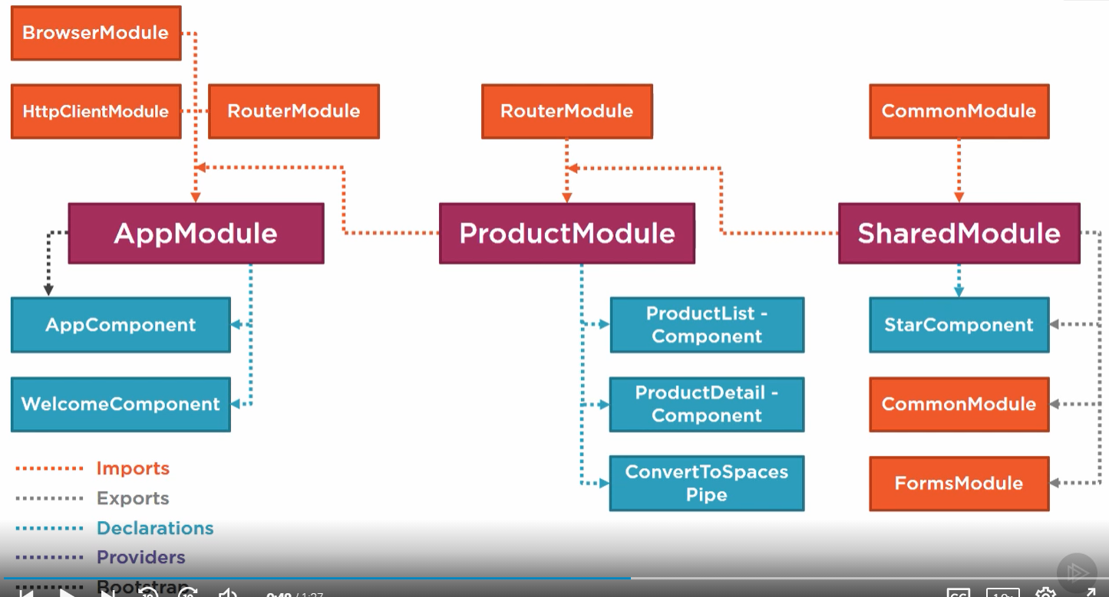

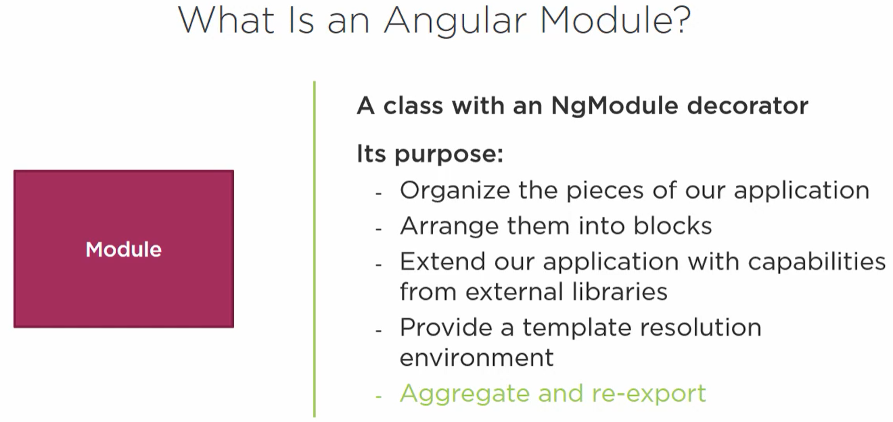

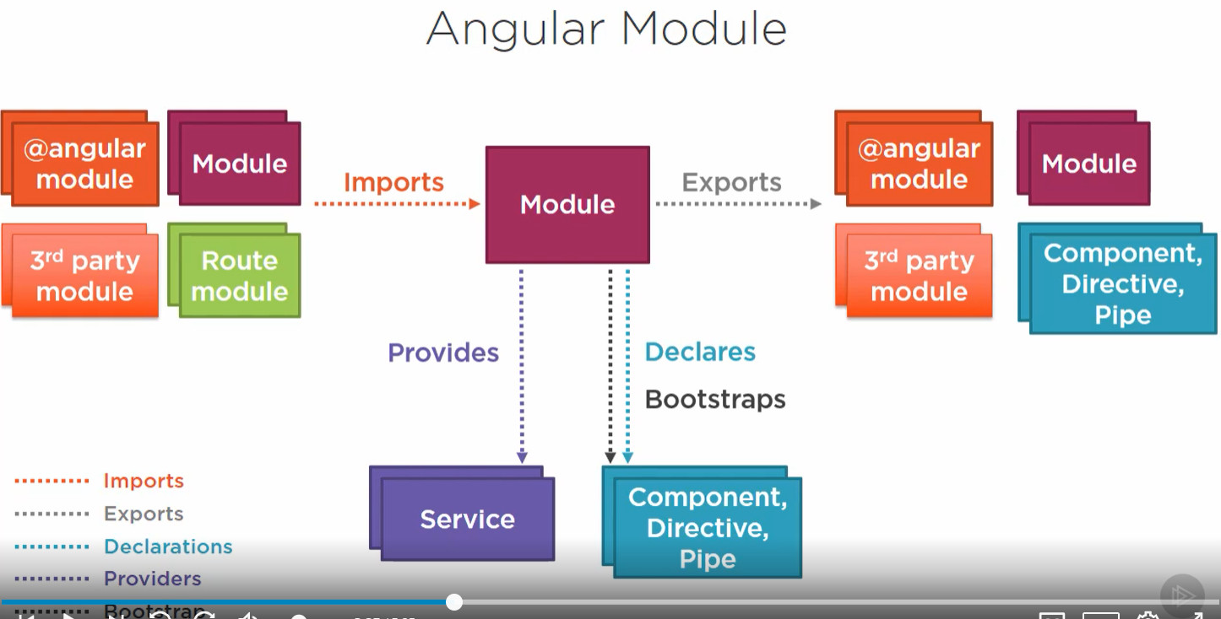

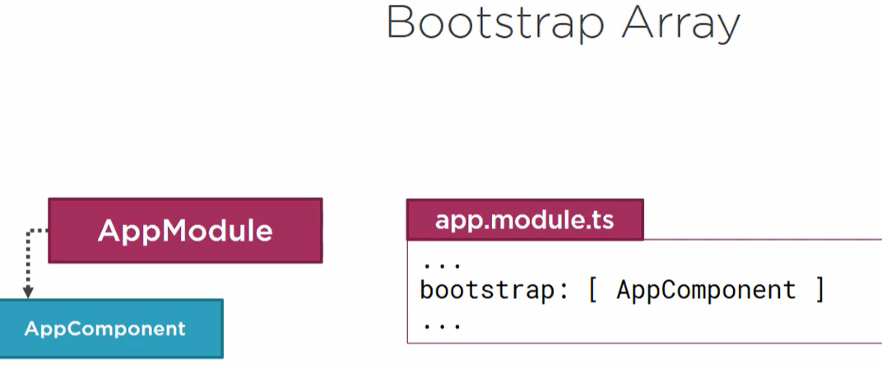

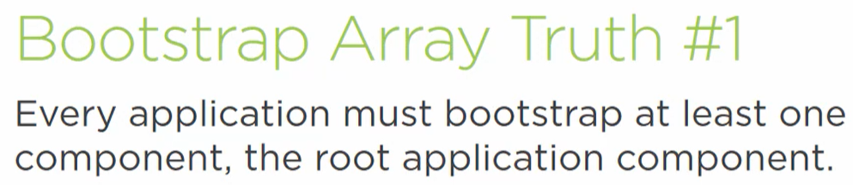

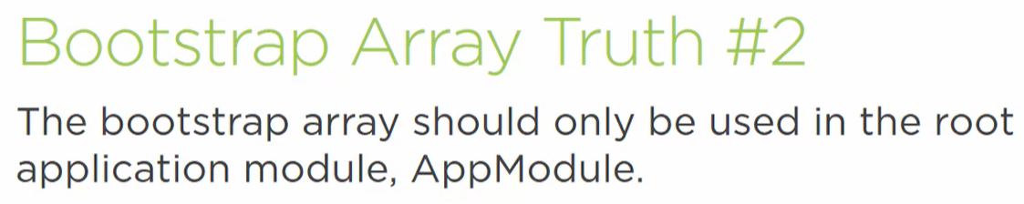

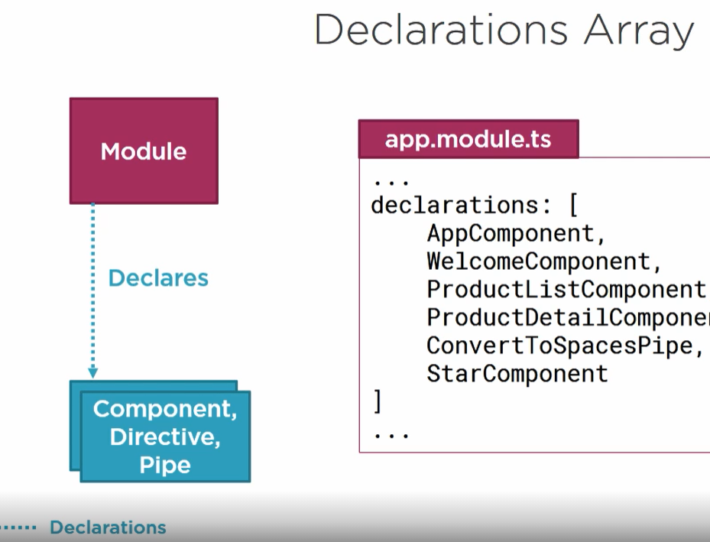

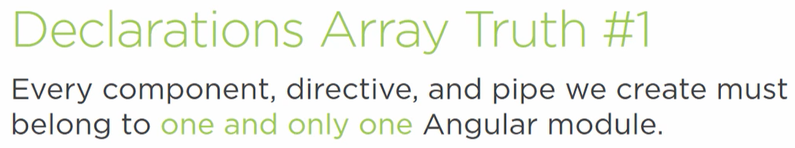



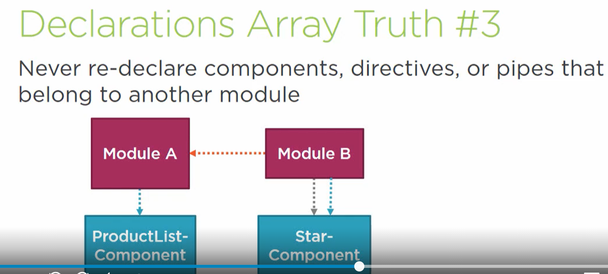

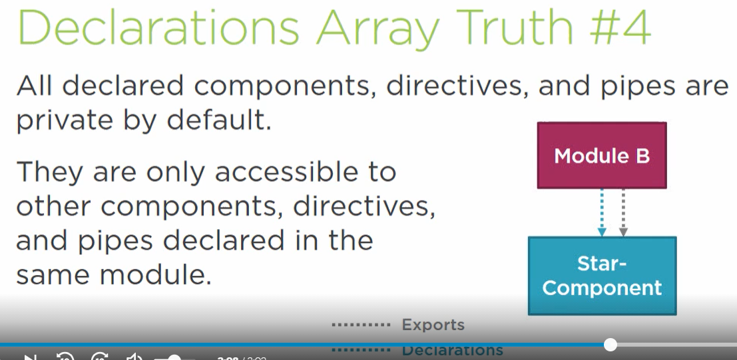

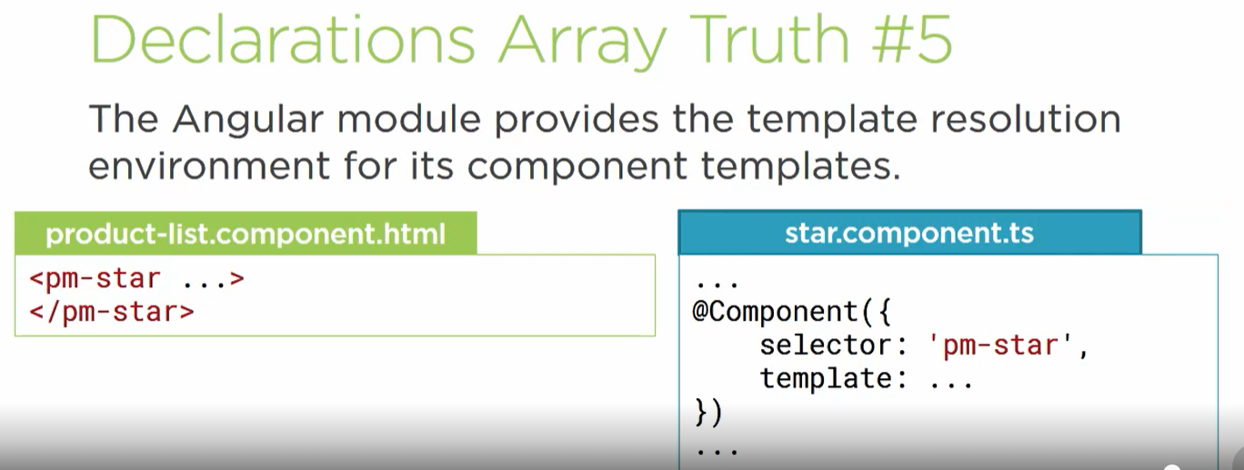

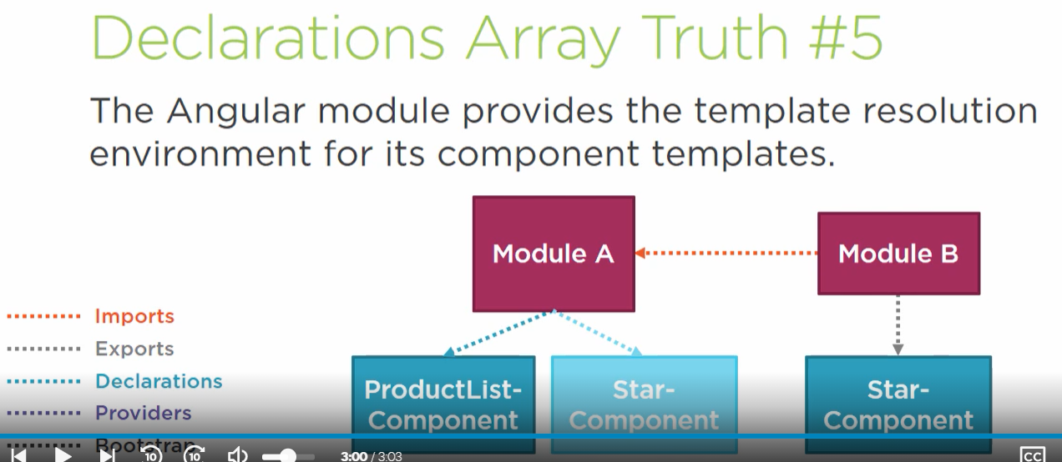

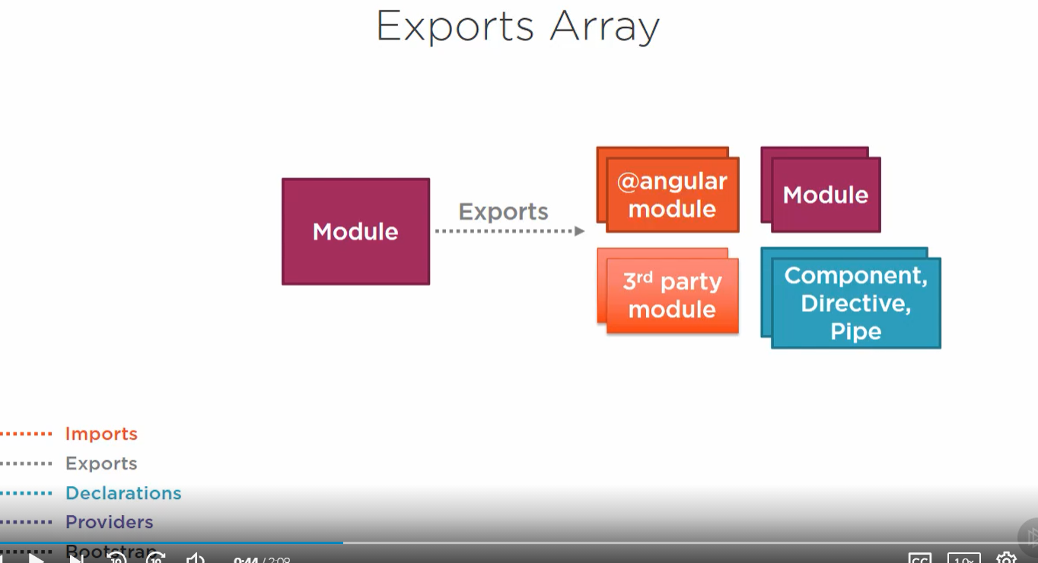

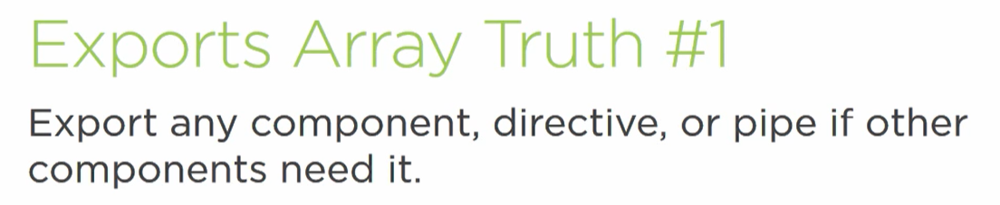

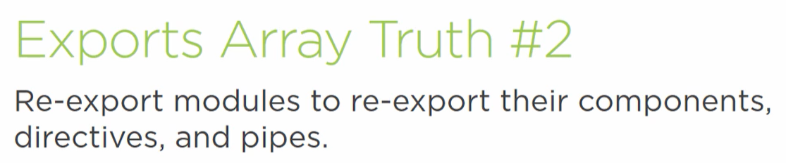

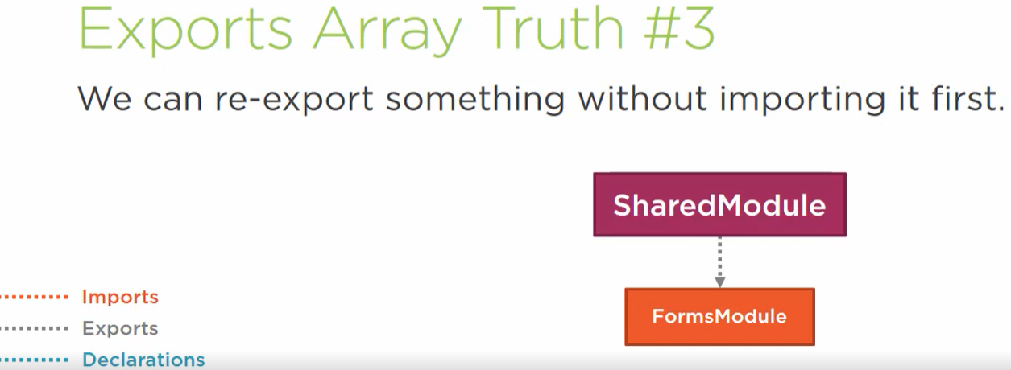

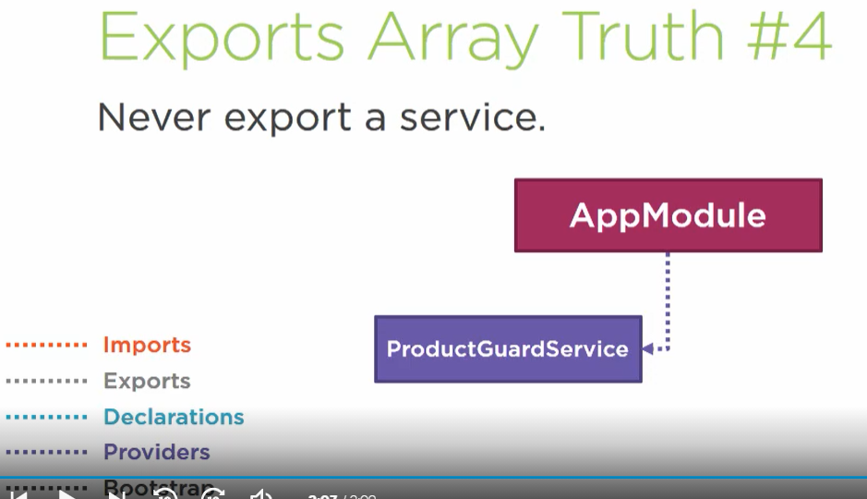

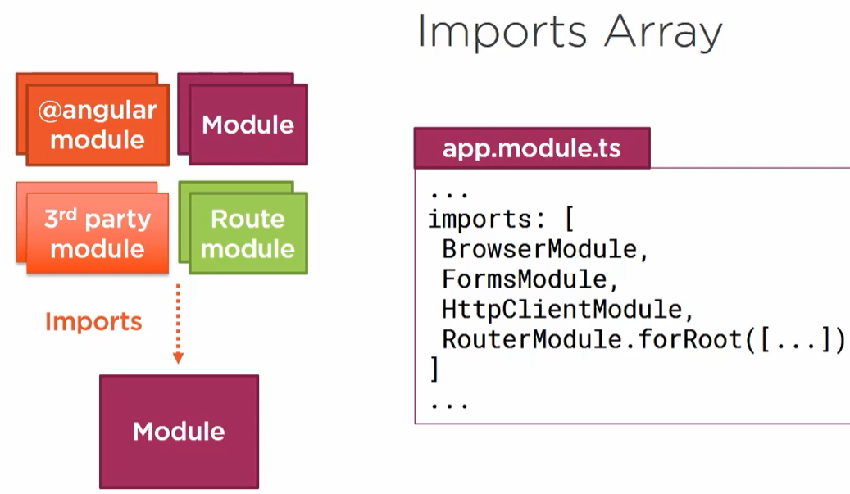

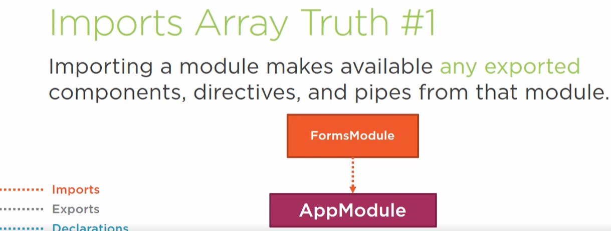





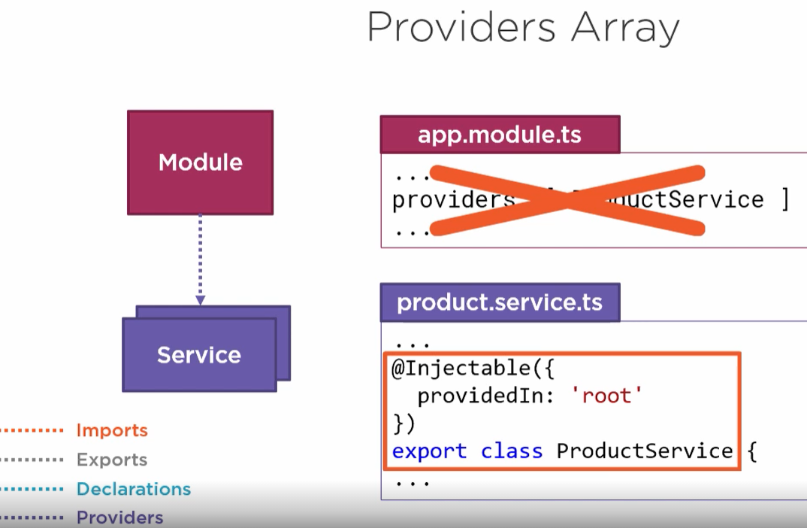

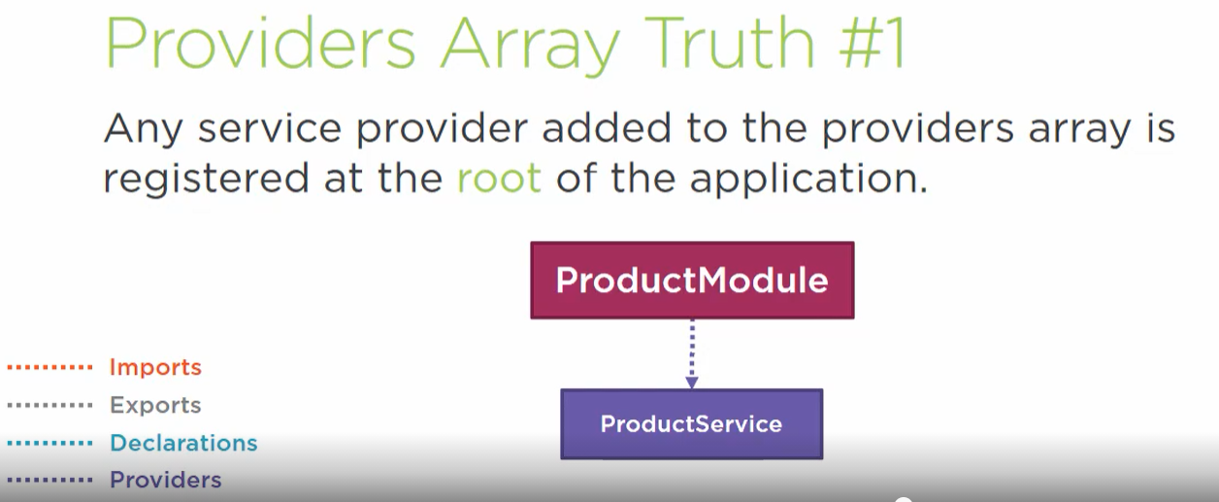

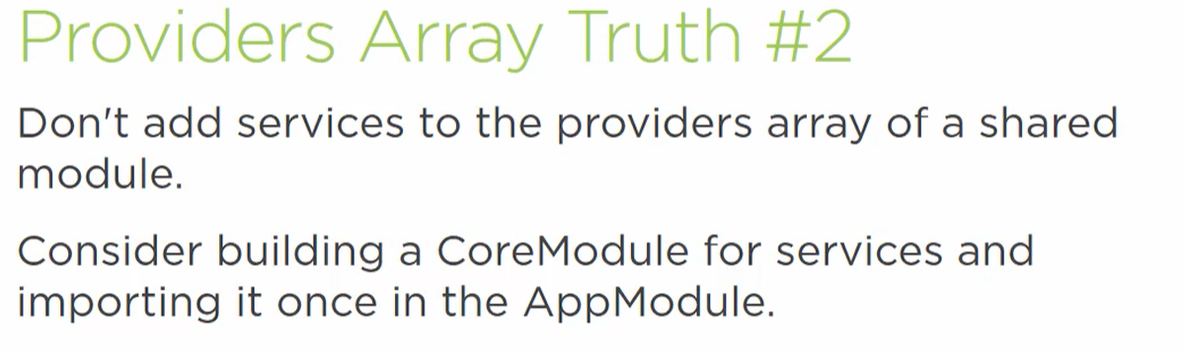

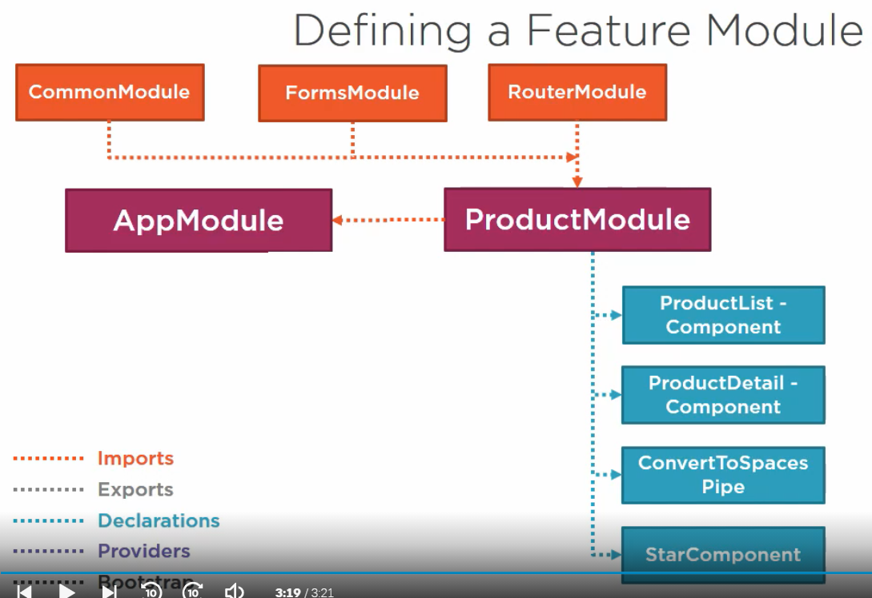

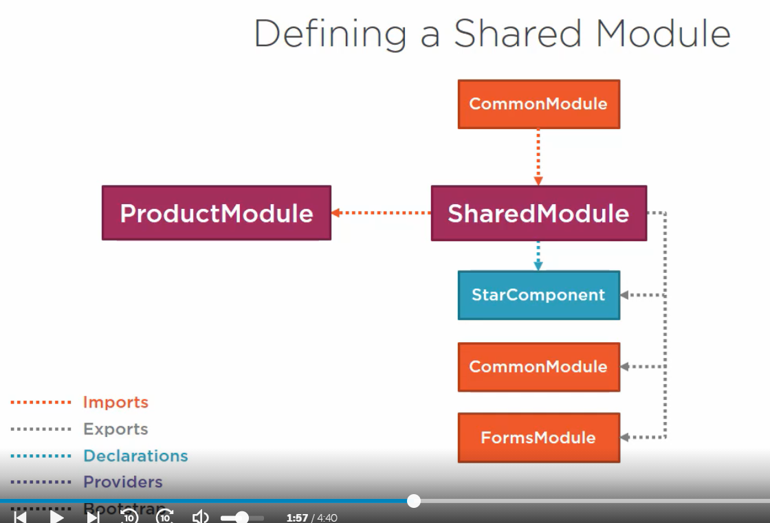

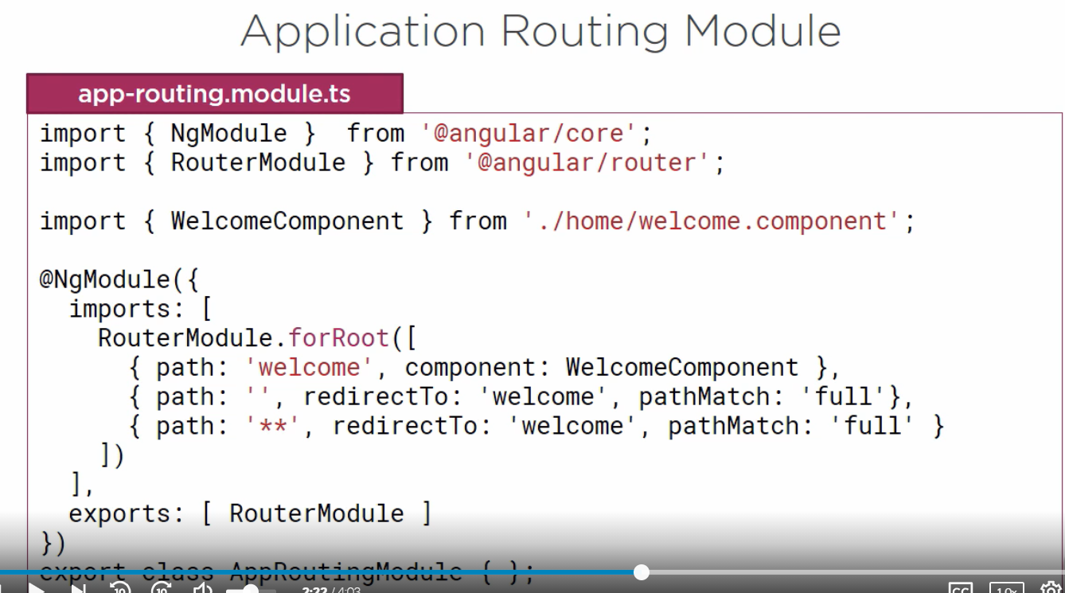

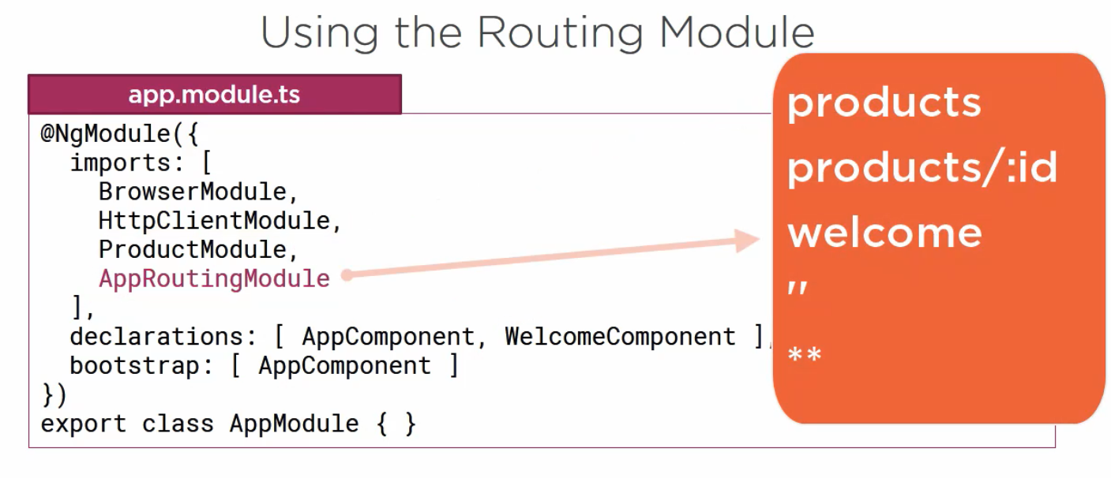

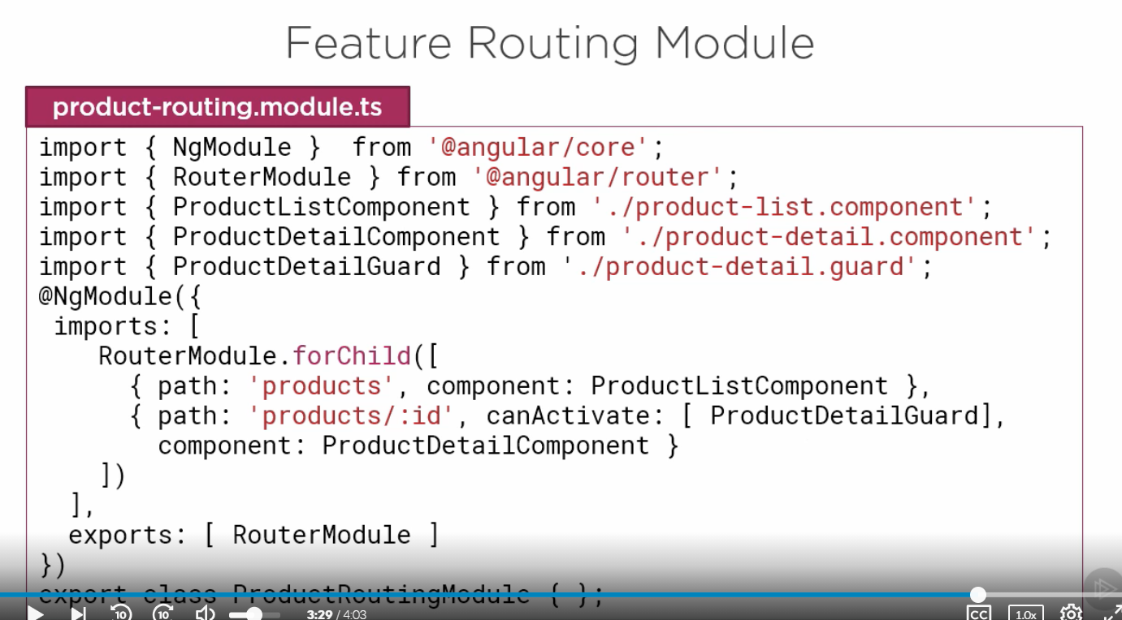

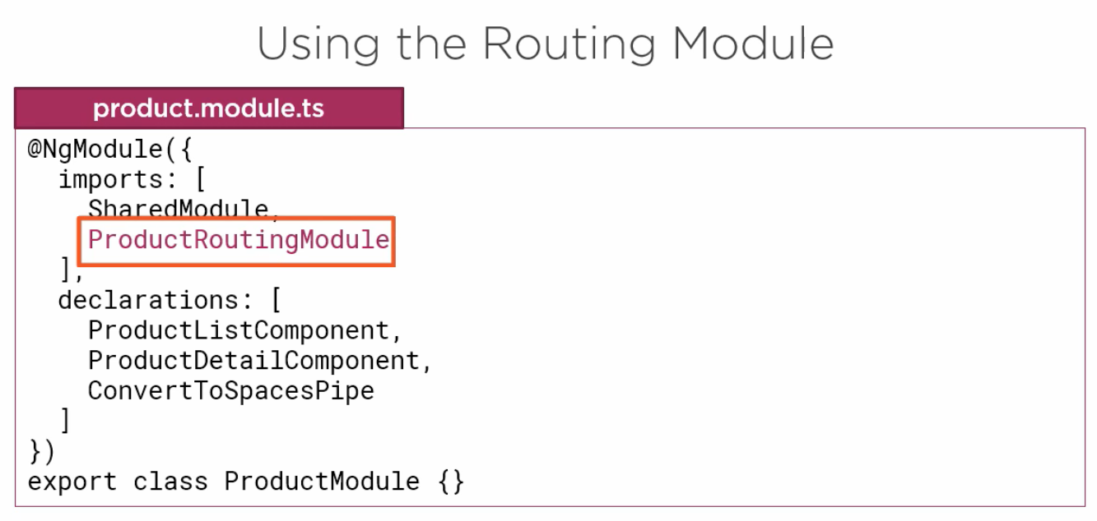

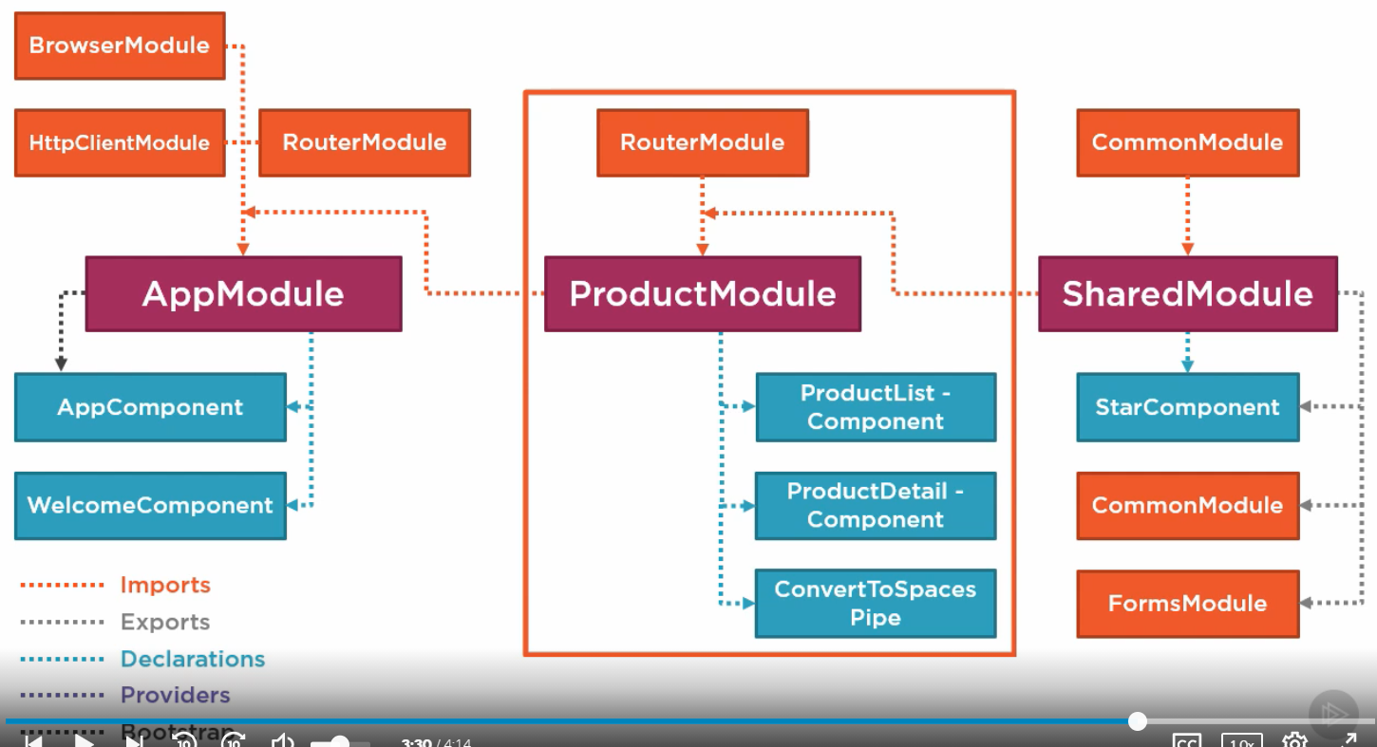

**Bootstrap of angular app from main.ts**

**main.ts**

This is the main entry point for our angular application and this is where application bootstrap method is called for our root module.

If we look at our main property file, angular.json, we will see that it is pointing to the main.ts component. It is just like our java class that has the public static void main( String s[] ) method.

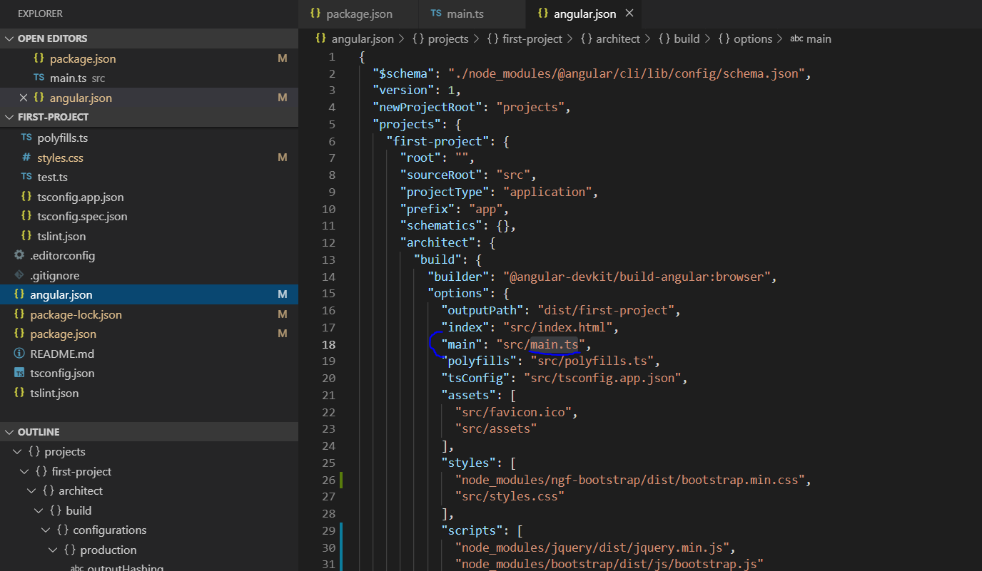

This causes the main.ts files to load when our app first loads.

Then we can see in the main.ts that is bootstrapping the application with the AppModule.

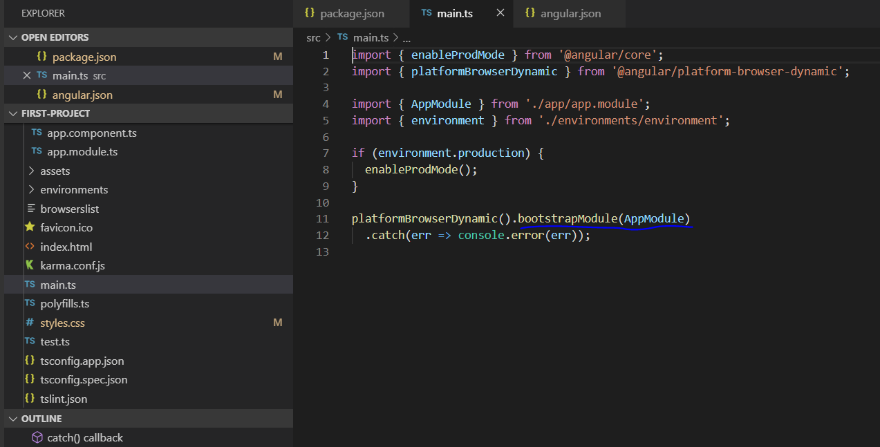

So if we remember every angular application is grouped under modules and every angular will have an AppModule and this AppModule is defined in the app.module.ts. The AppModule bootstraps with the AppComponent. So that’s how the angular knows about the AppComponent.

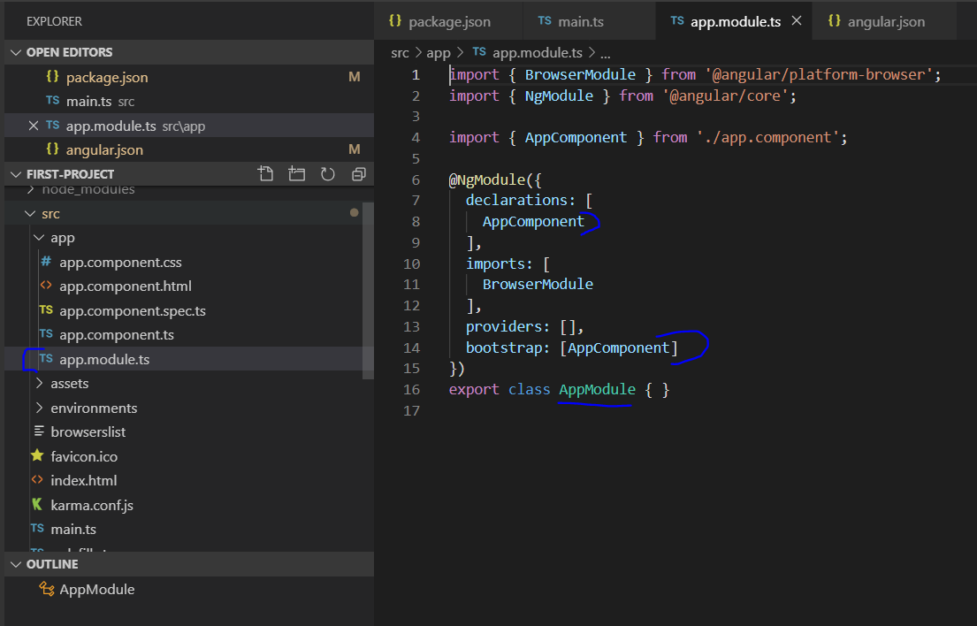

So, this makes angular aware of our component, but how do we ask the angular to **display** our components. So, if we see our AppComponent present inside the app.component.ts, we will see a selector **app-root**.

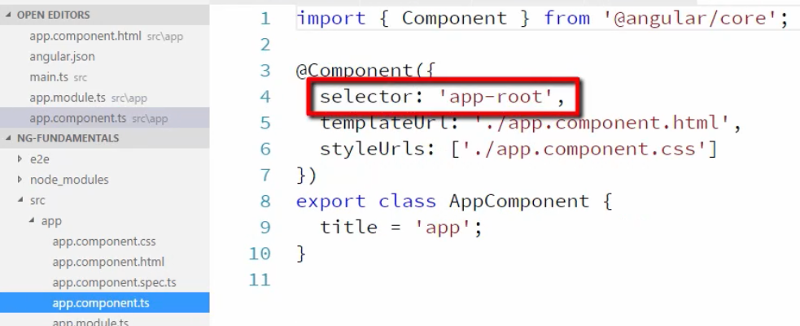

We will see this app-root selector used in the index.html

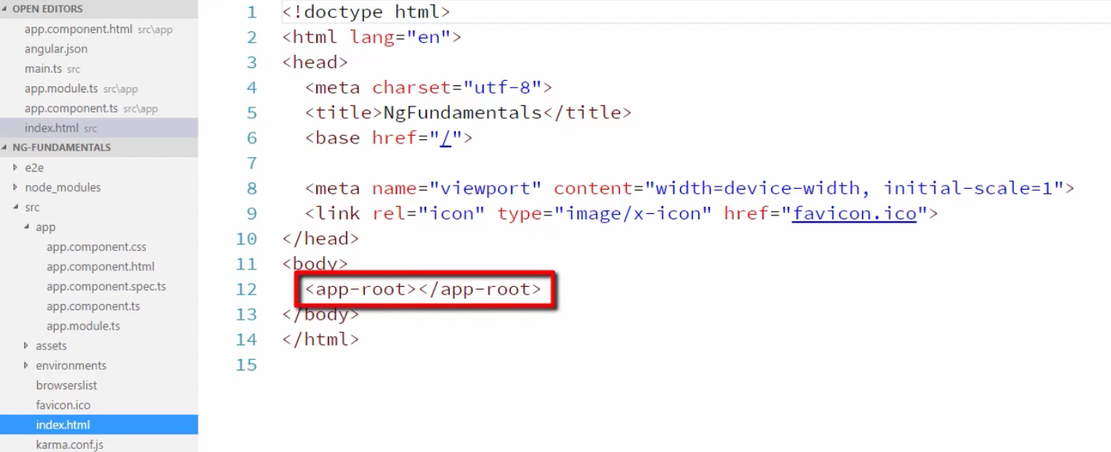

So, this is the index.html that is first displayed and it is loading our AppComponent. So that’s how everything comes together.

**How to bootstrap angular app**

Now just to show that nothing is magical let’s rename AppComponent and do some renaming and deleting of existing things.

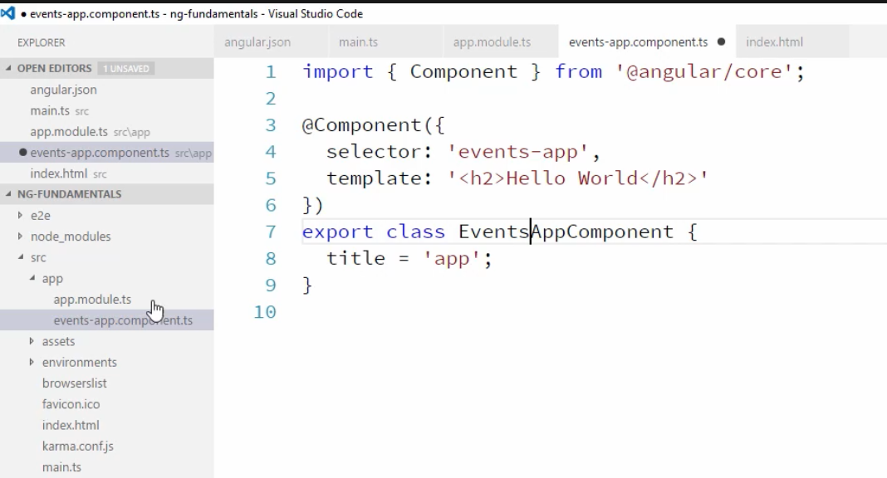

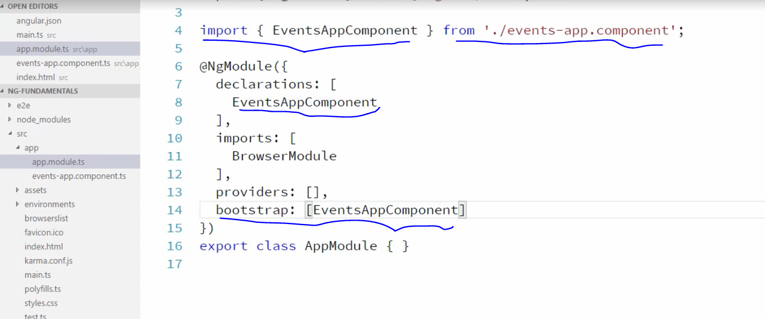

So, we change everything from the basic AppComponent to EventsAppComponent. So basically, at the bootstrap we are telling angular that which is our top-level component. In this case we are telling angular to **bootstrap** with EventsAppComponent.

No, the last place to change is in the index.html. This is file that angular load for the display by default, after reading it from the main property file angular.json

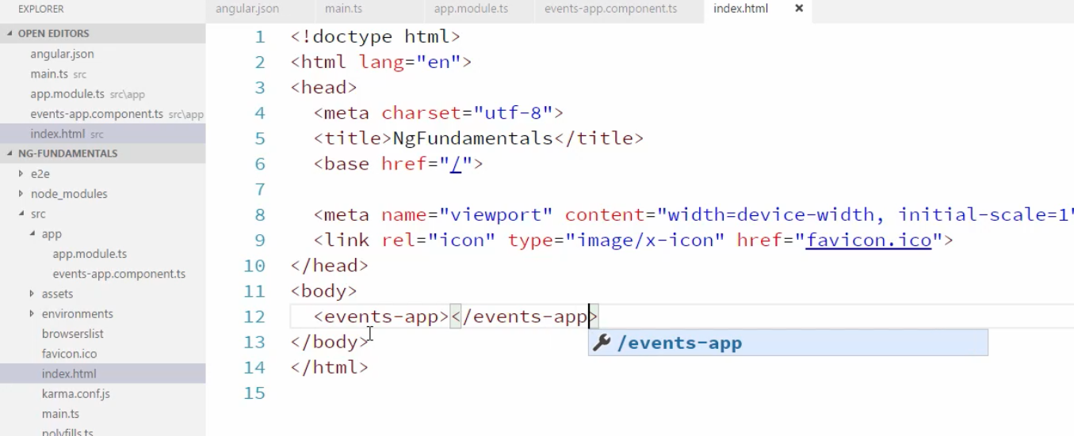

**Now let’s discuss about the three sections present inside the Modules.**

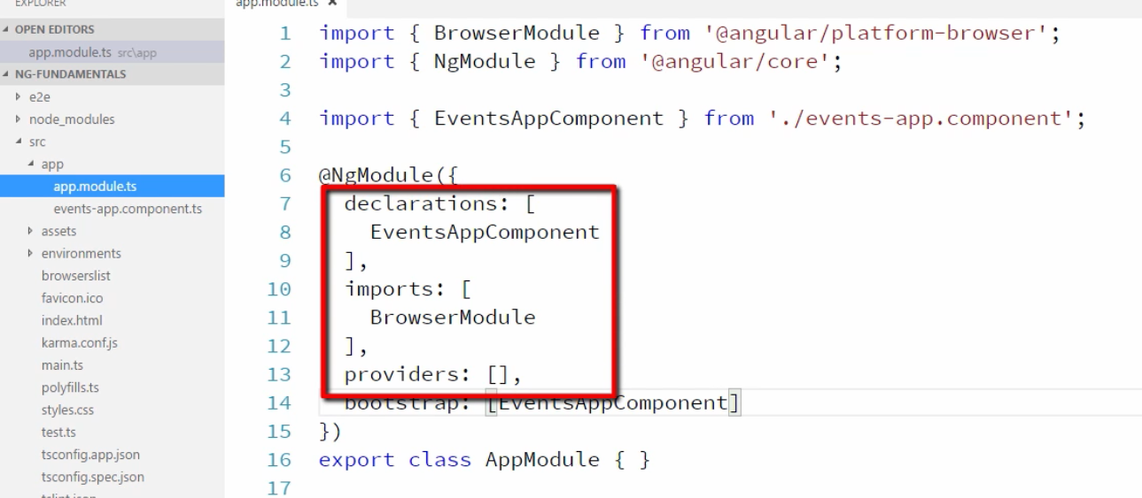

**Declarations**

Use for adding the component, pipe or directive

**Imports**

Used for importing the other modules.

**providers**

Used for adding the services.

**How to add Static files like images**

Inside the src folder we have the assets folder. This assets folder is the place where we add our static files. Let’s create an image folder inside this assets folder. We will now save some images inside images folder.

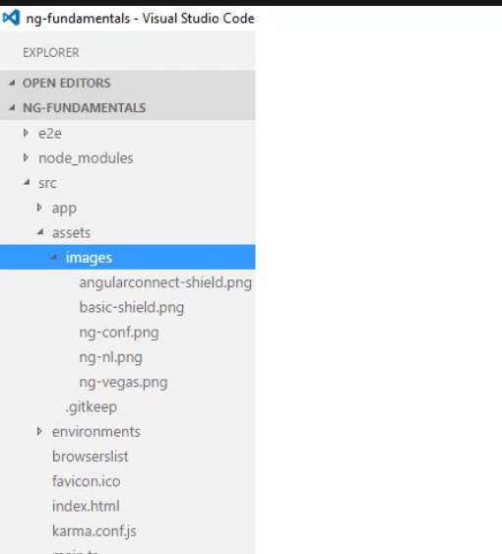

Now let’s add this image in our app, like below

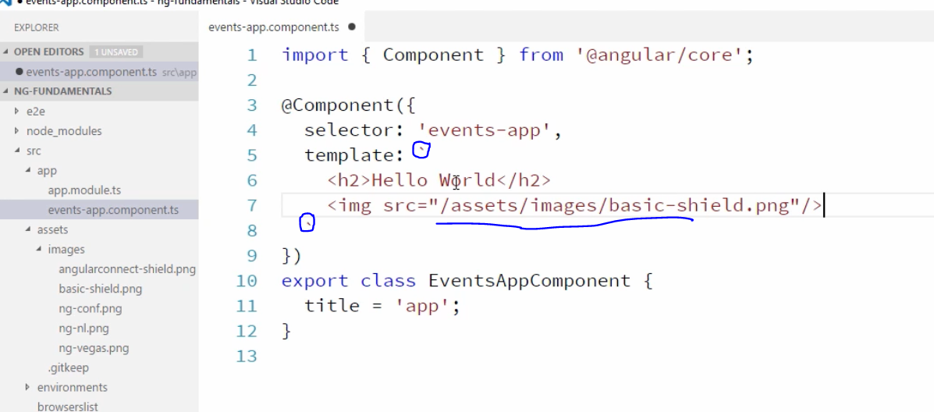

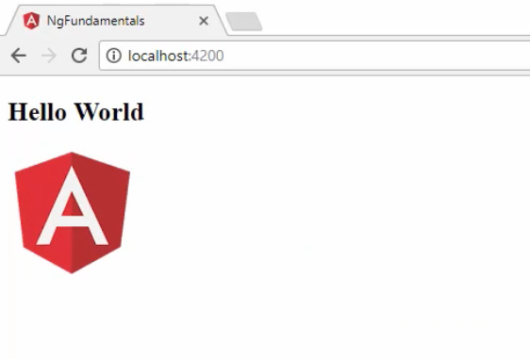

If we notice in our app, we have given relative path to add the images src like /assets/images……. Well this path is relative to the index.html

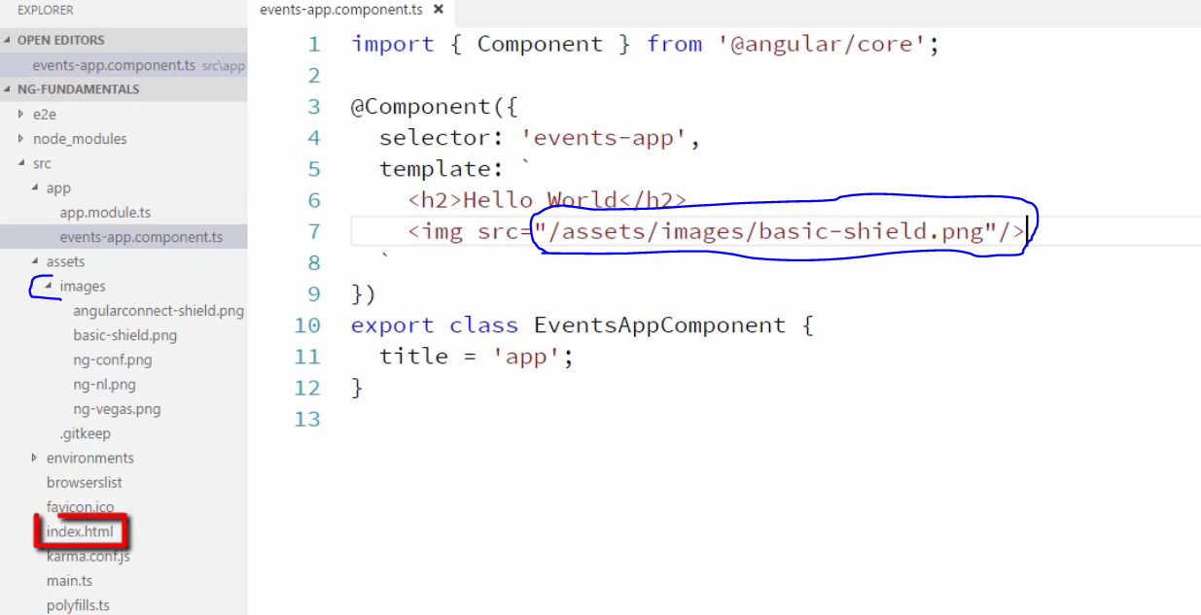

But you cannot statically access any file that is relative to index.html file. Webpack needs to know which file to bundle up when it builds the app. So, the only reason why it is working, is when you look in our angular. json, the assets folder is included in the assets array. This array is an array of path, that we would like webpack to include in our app bundle and these paths are relative to our angular.json file or the root of our site. So that’s how we make files statically available to our app.

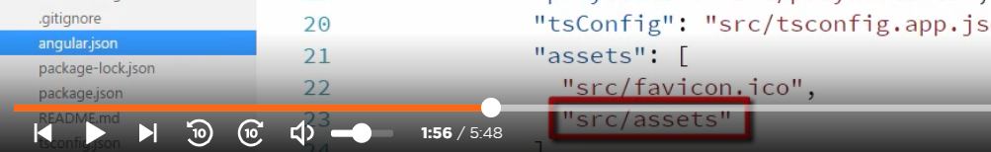

To add JavaScript and CSS, there is different convention. For this we have **styles** and **scripts** arrays.

Now let’s see how we can add some third-party vendor scripts and CSS. For example, twitter bootstrap CSS library.

**npm install ngf -bootstrap --save**

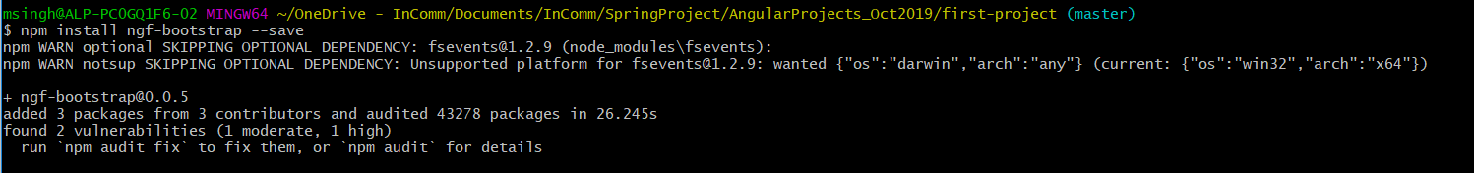

In case if we want to load some static contents like images of CSS or any JS we can specify them in the angular.json. This is just like adding the dependency in the pom.xml

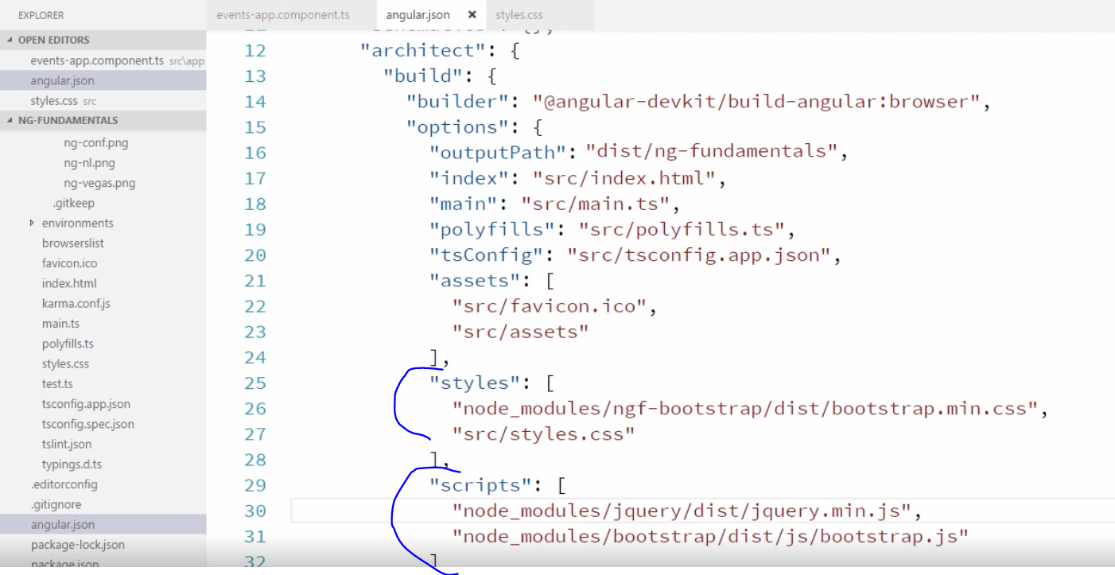

Now let’s start (**npm start** or **ng serve**) the app and add the bootstrap container and see the look.

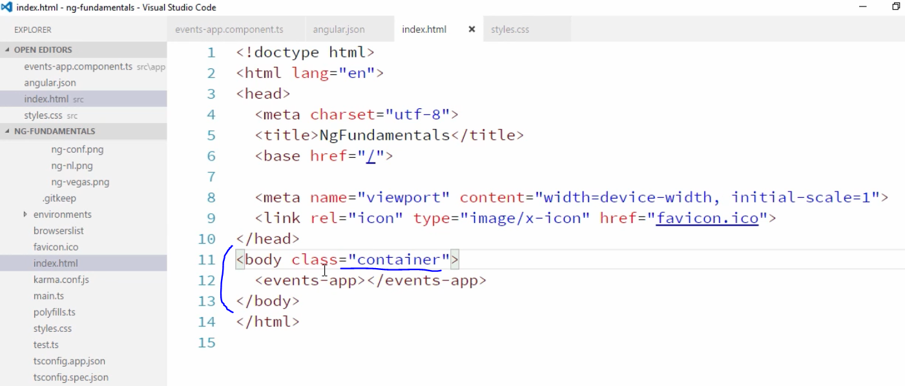

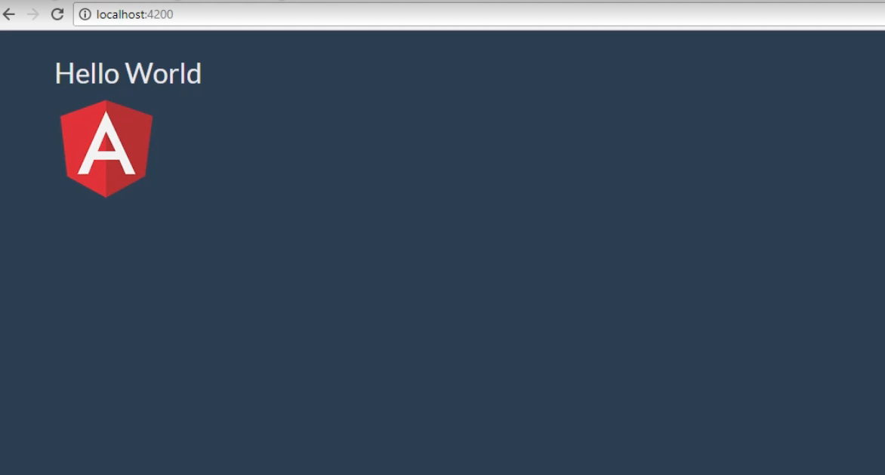

Angular Conceptual Overview:

@Input : it is a decorator that tells angular, that a particular object or property will be passed in from another component.

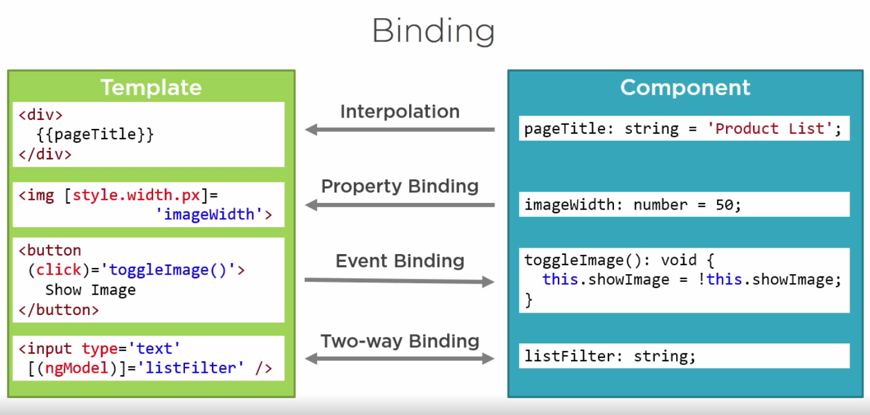

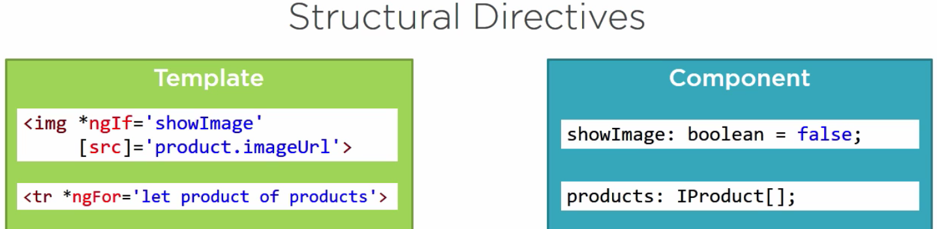

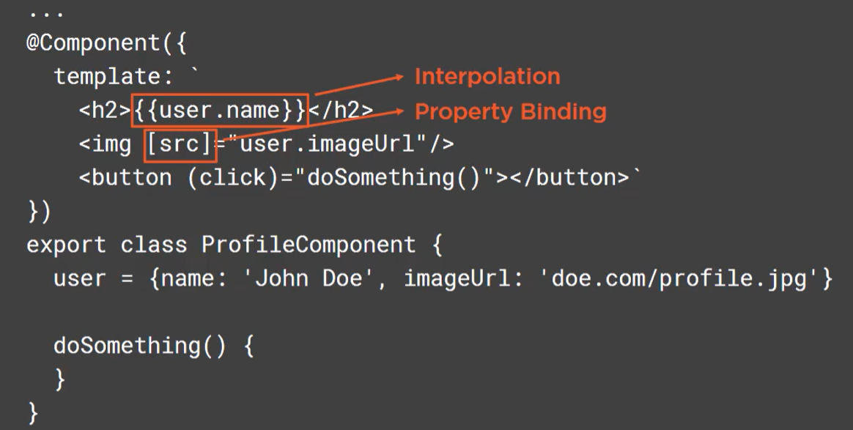

Both interpolation and property binding is used to bind data from the component to the template.

Communincatoin between parent and child using emmiter.

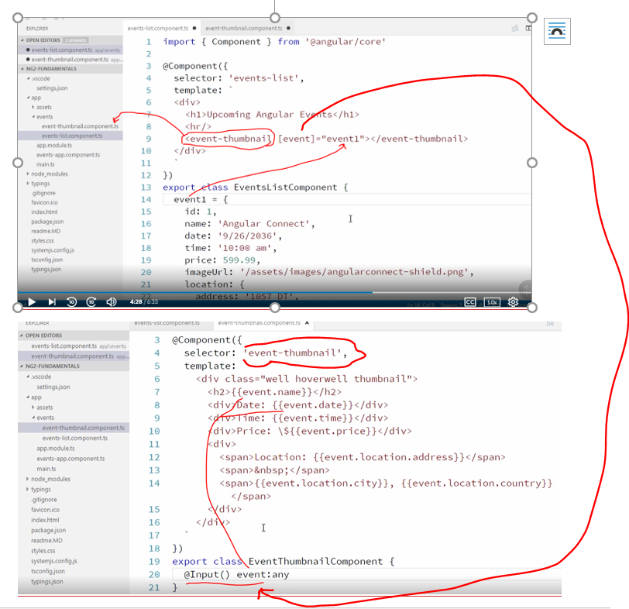

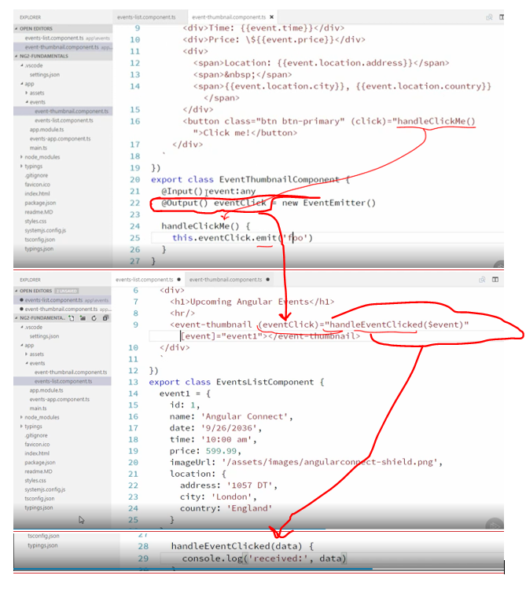

Using template variable on parent and calling the method on the child.

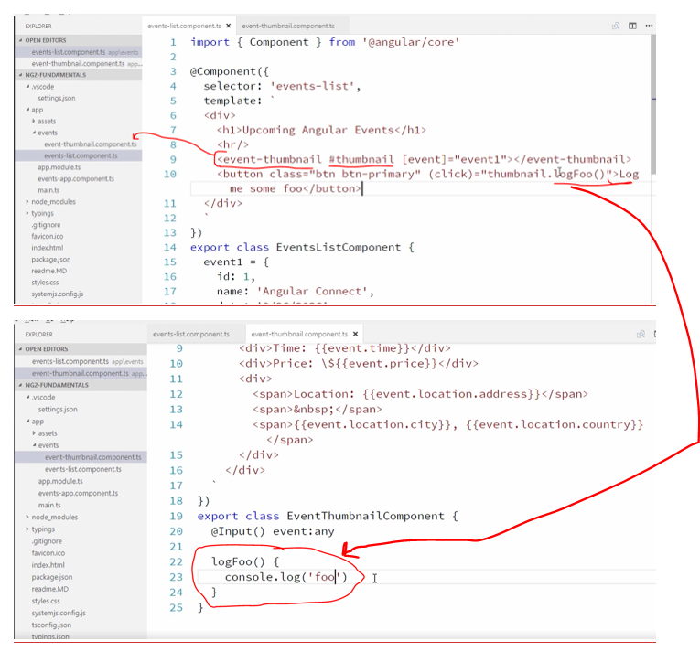

Binding through interpolation

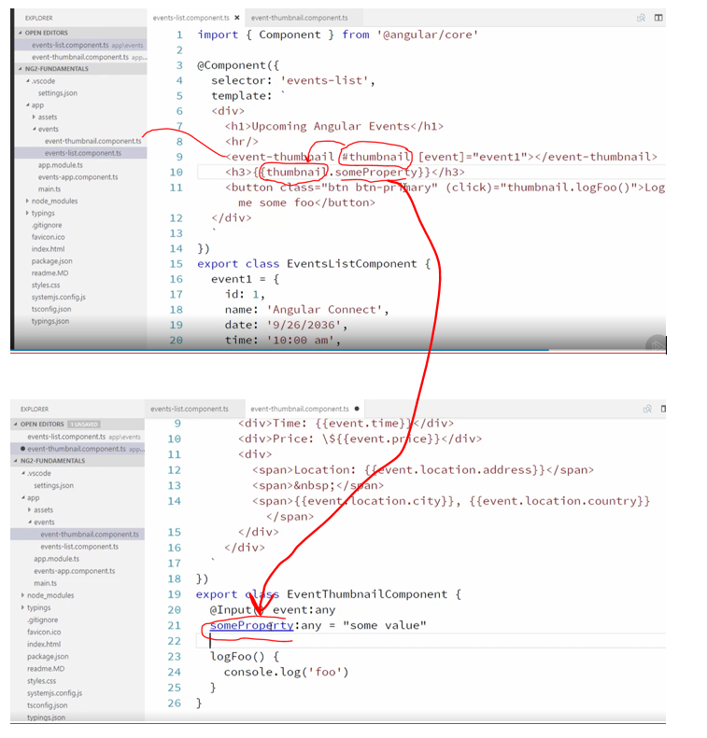

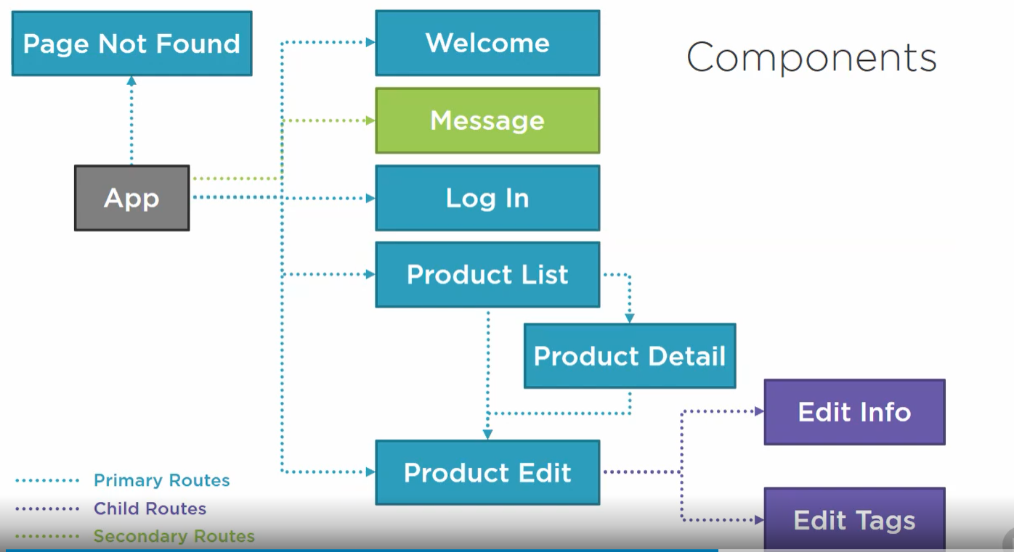

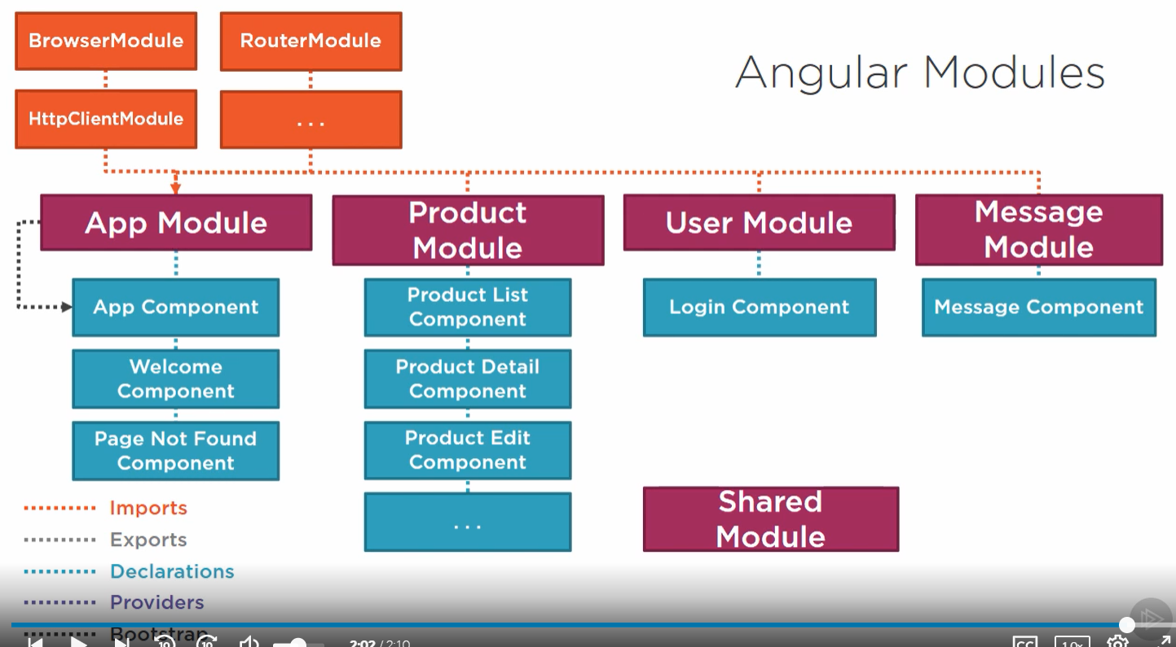

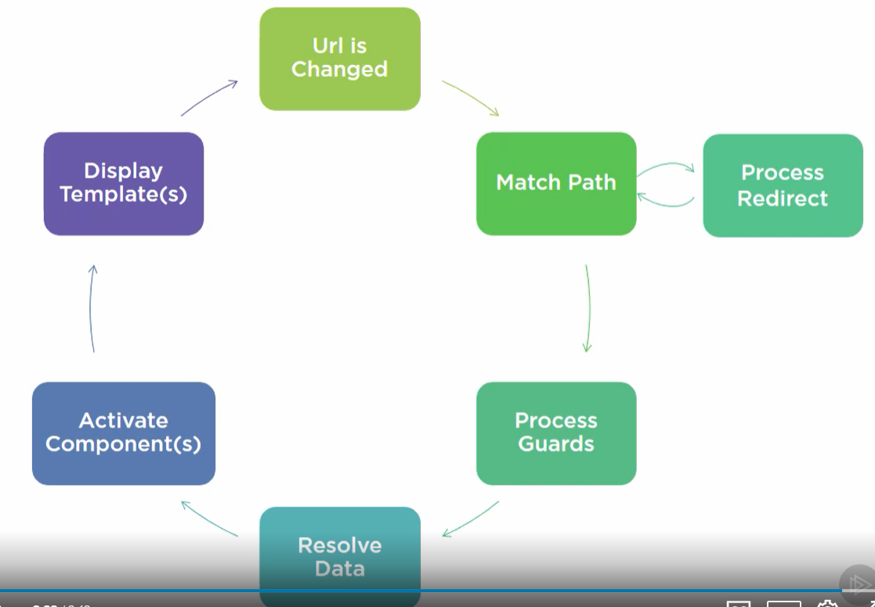

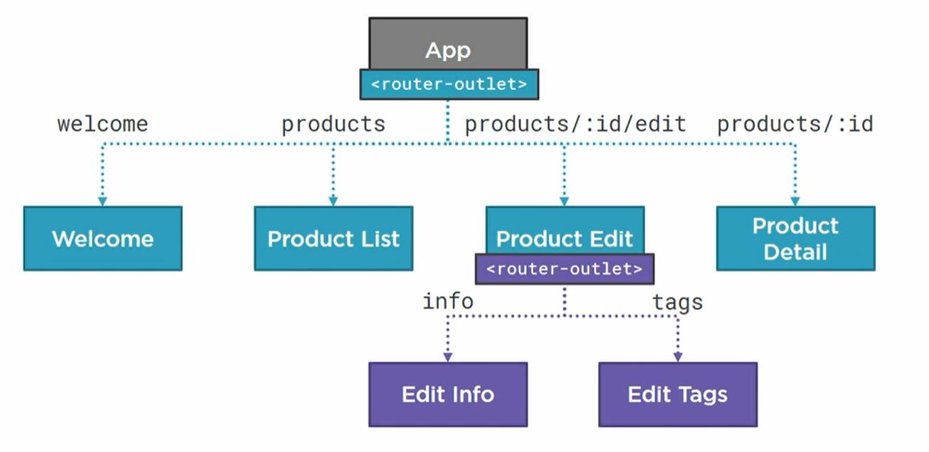

Reference:

<https://jcoop.io/angular-practice-exercises>

<https://github.com/jmcooper/angular-fundamentals-files>

<https://github.com/Deborahk/Angular-gettingstarted>

<https://github.com/dlbunker/ps-spring-boot-and-angular>

<https://www.youtube.com/watch?v=7OXE3pZ4Btk> : login user

<https://www.youtube.com/watch?v=T21CgIRnIp0>sidbar :

<https://zoaibkhan.com/blog/create-a-responsive-sidebar-menu-with-angular-material/>

https://tburleson-layouts-demos.firebaseapp.com/#/docs